**Python Basics**

**OPERATORS**

**1.Arithmetic Operators**

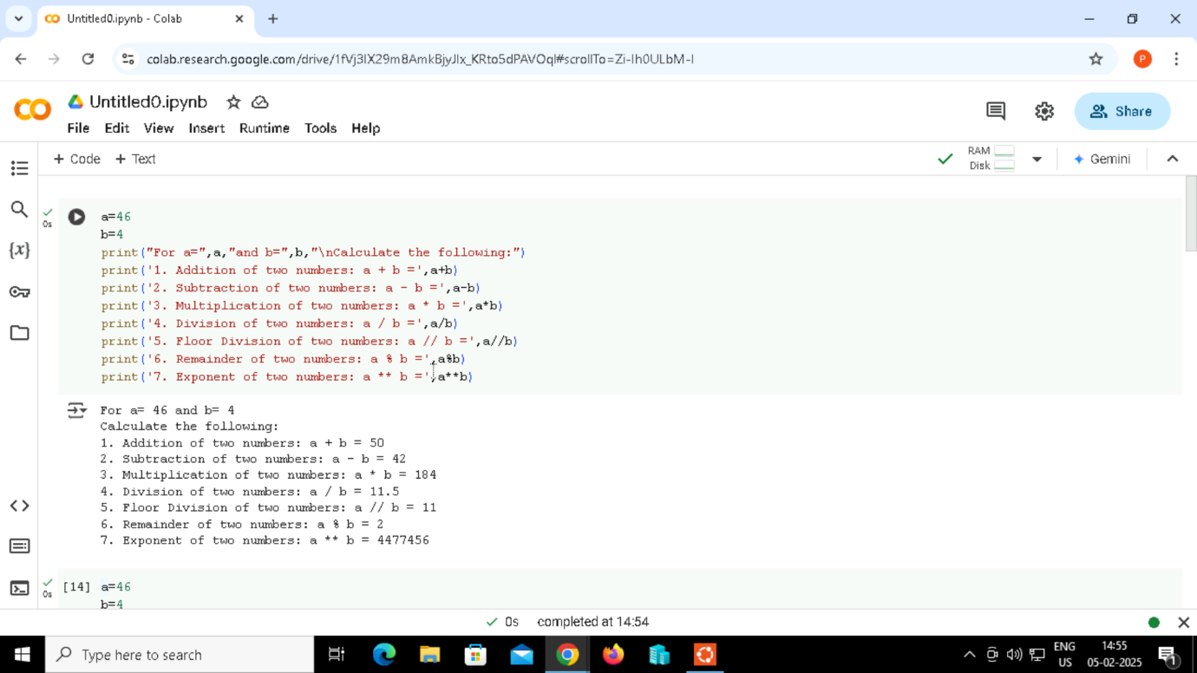

Output:

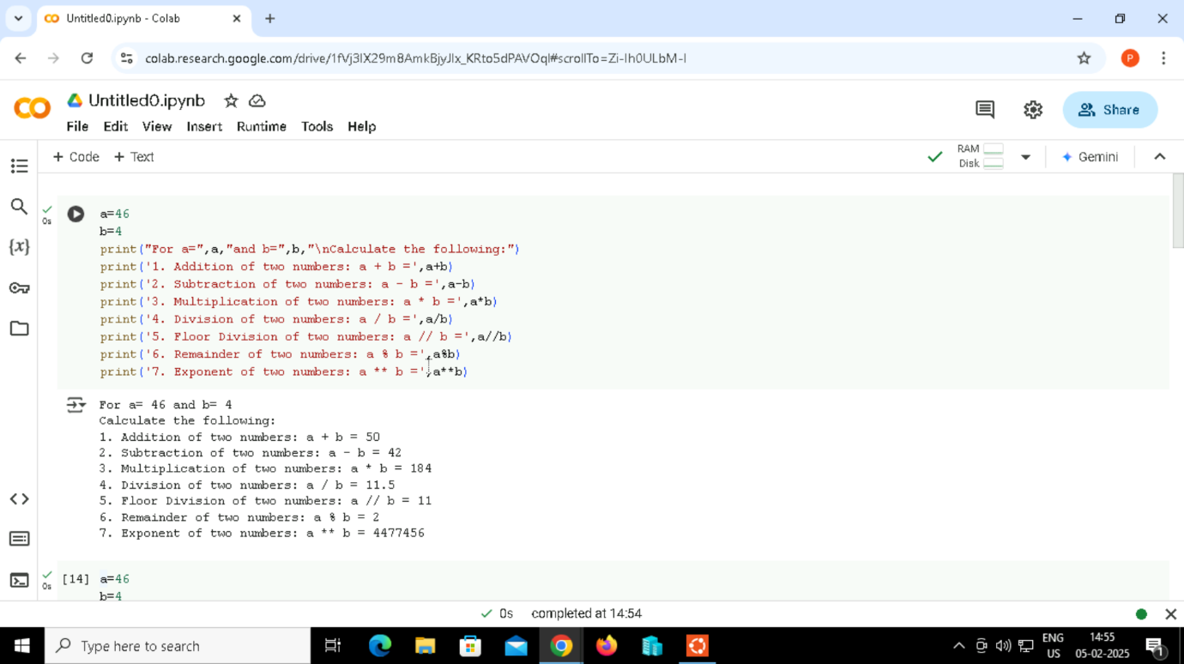

2. Comparison Operators

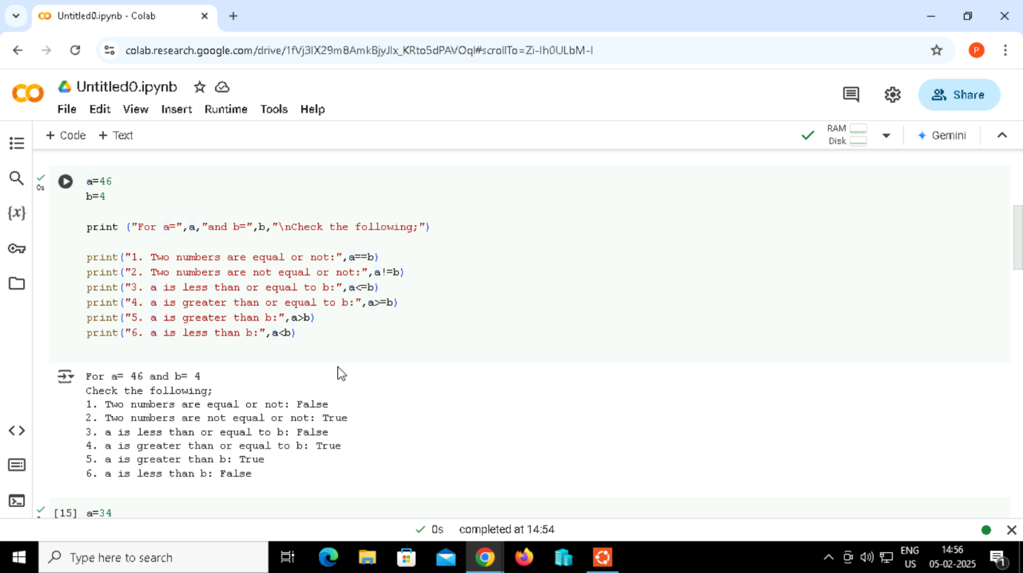

Output:

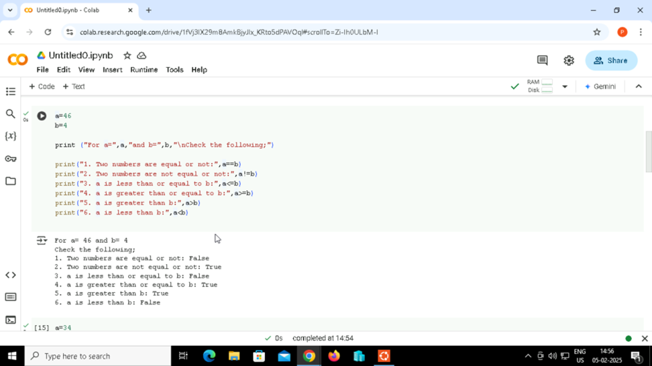

3.Assignment Operators

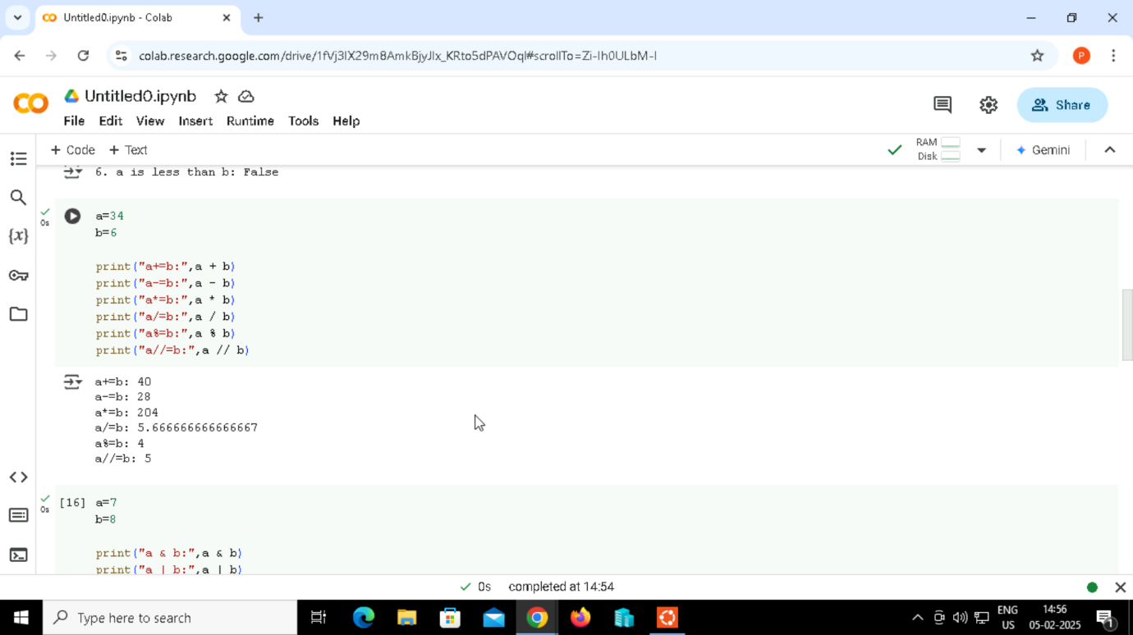

Output:

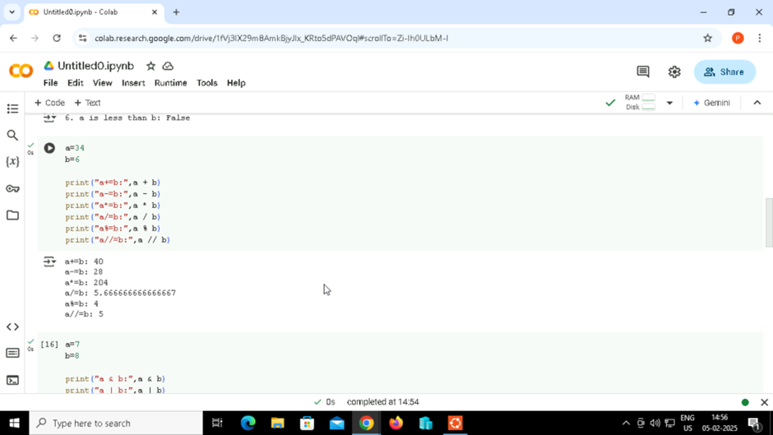

4.Bitwise Operators

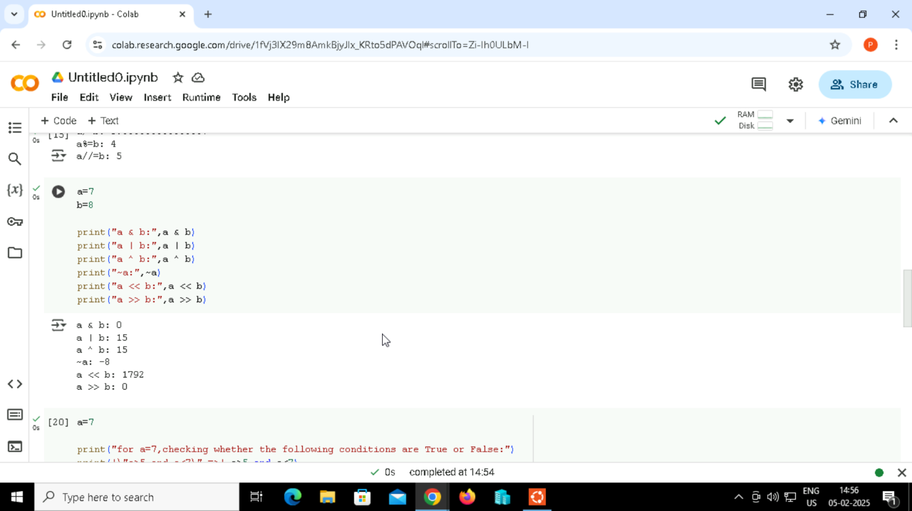

Output:

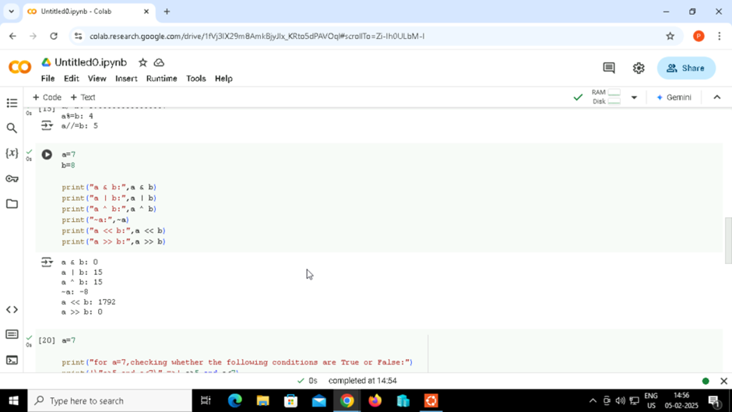

5.Logical Operators

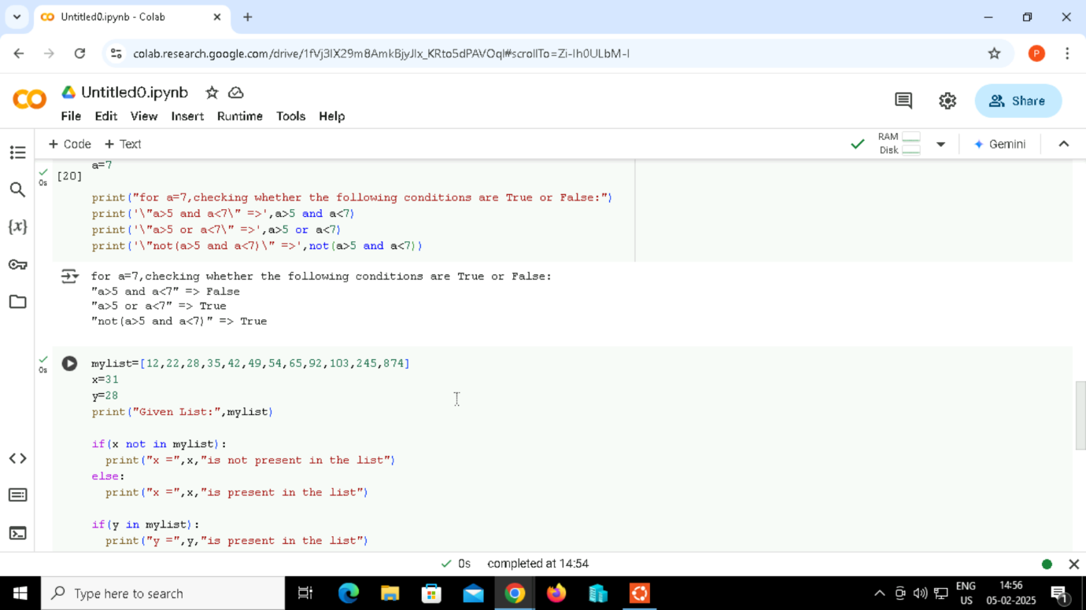

Output:



6.Membership Operators

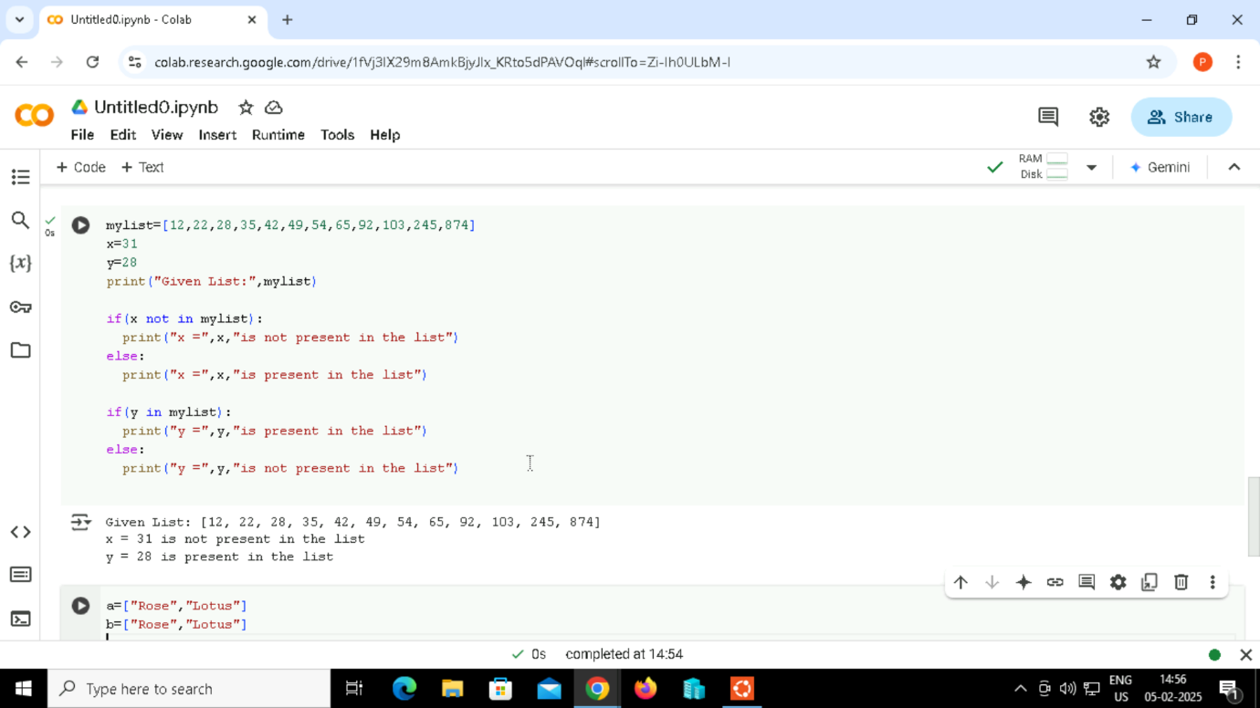

Output:



7.Identity Operators

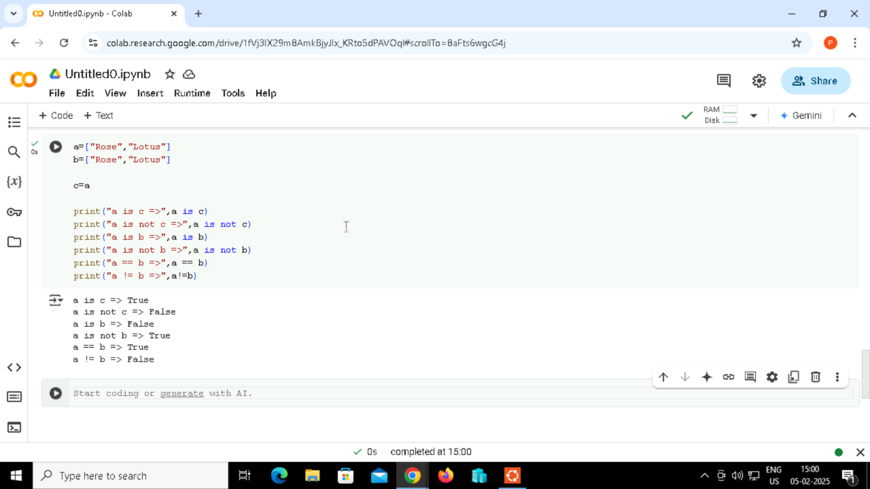

Output:

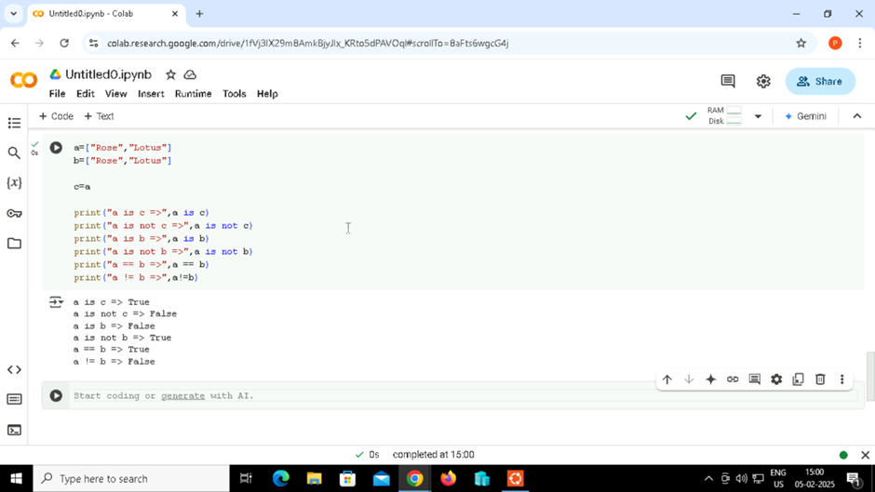

8. How to read csv file in python

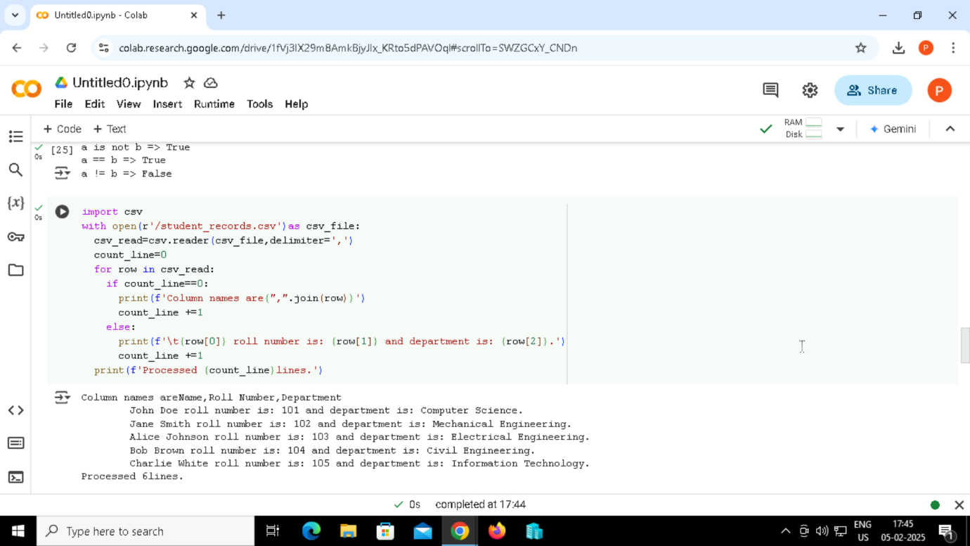

Output:



How to reverse a string in python

9.Using for loop

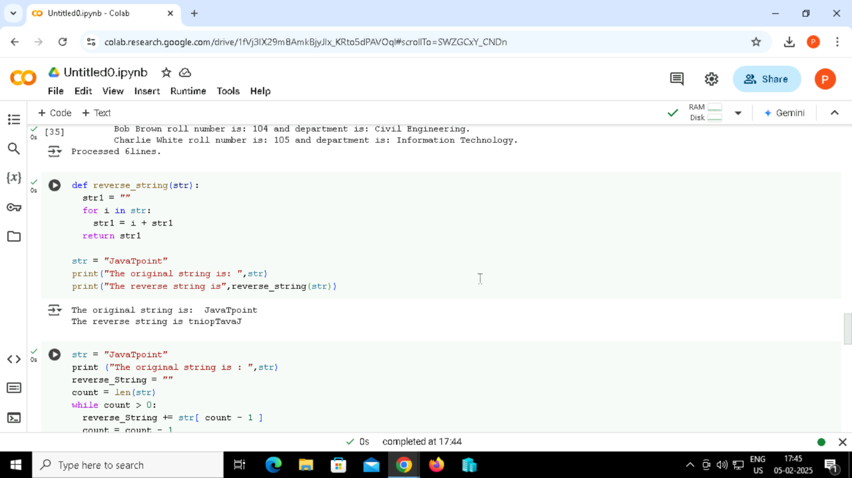

Output:



10. Using while loop

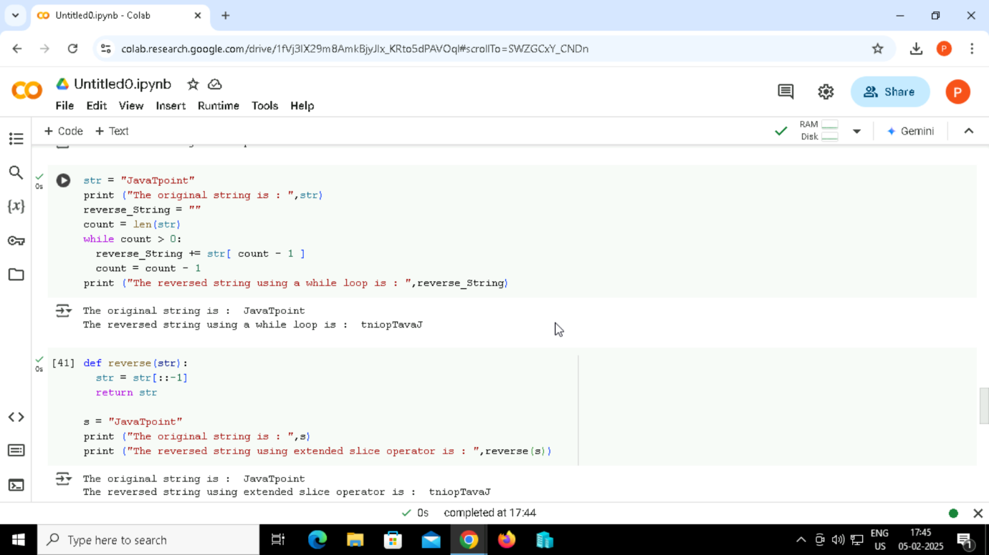

Output:

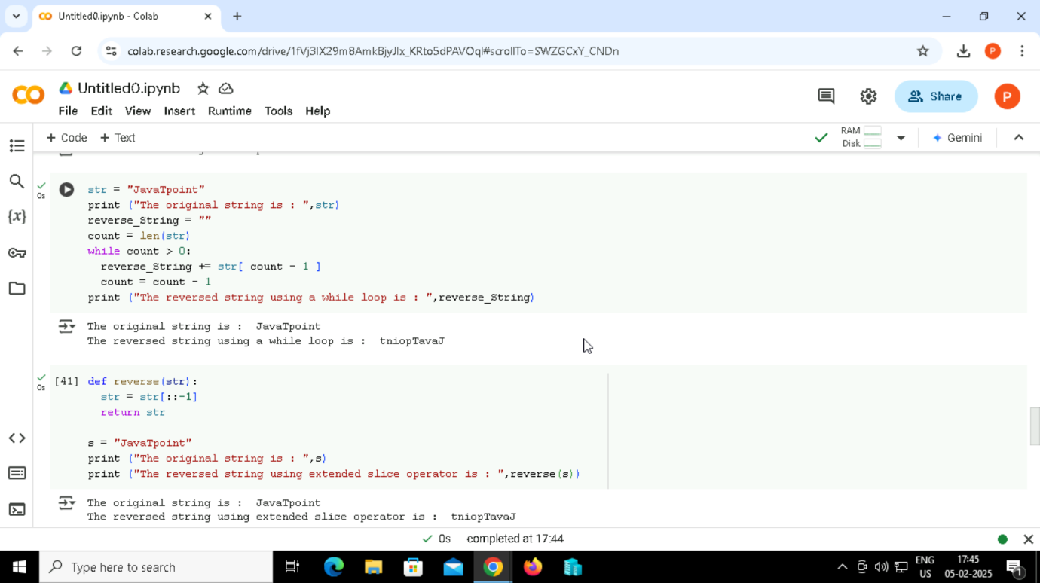

11. Using the slice([]) Operator



Output:



12. Using reverse function with join

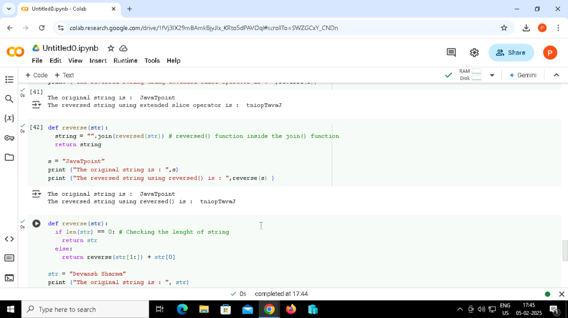

Output:

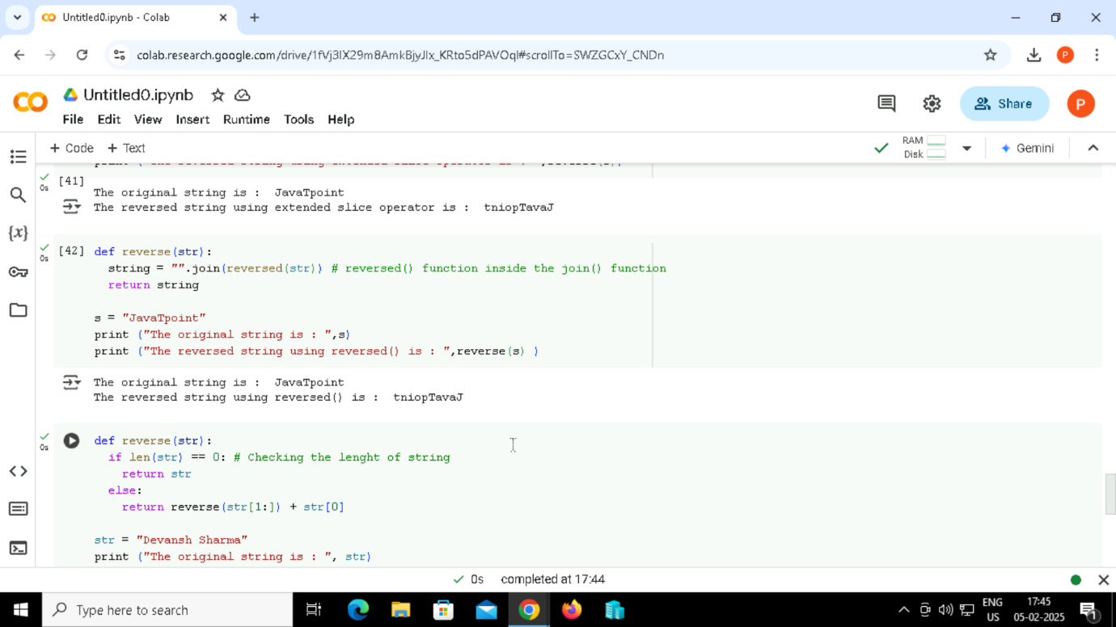

13. Using recursion ()

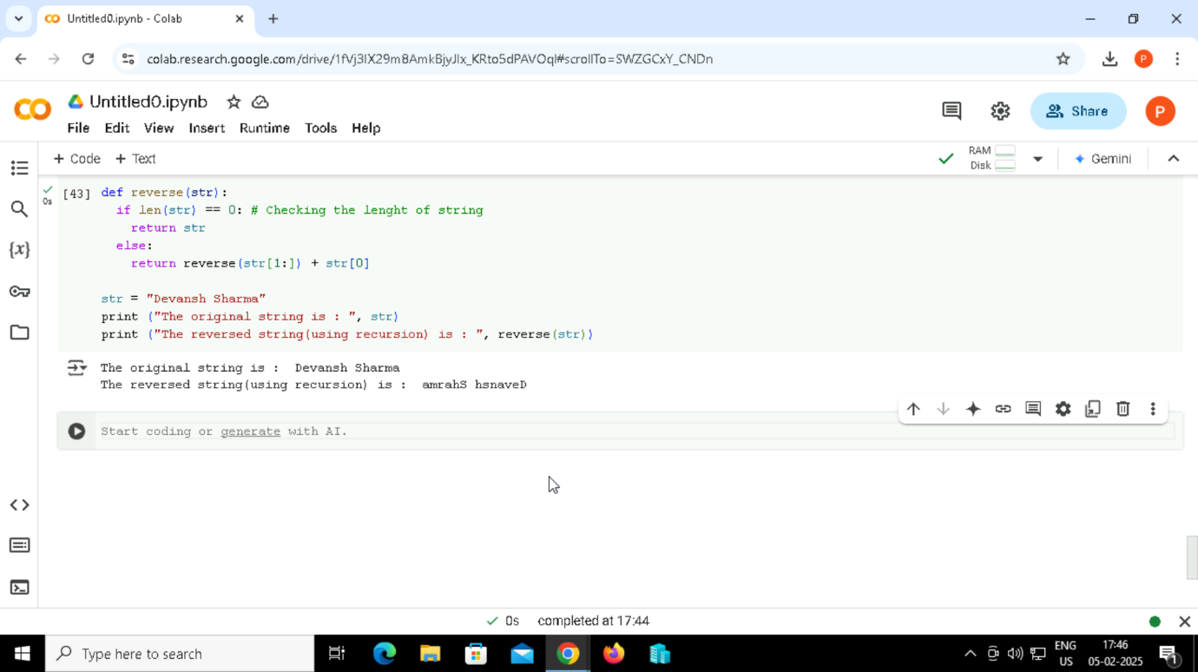

Output:

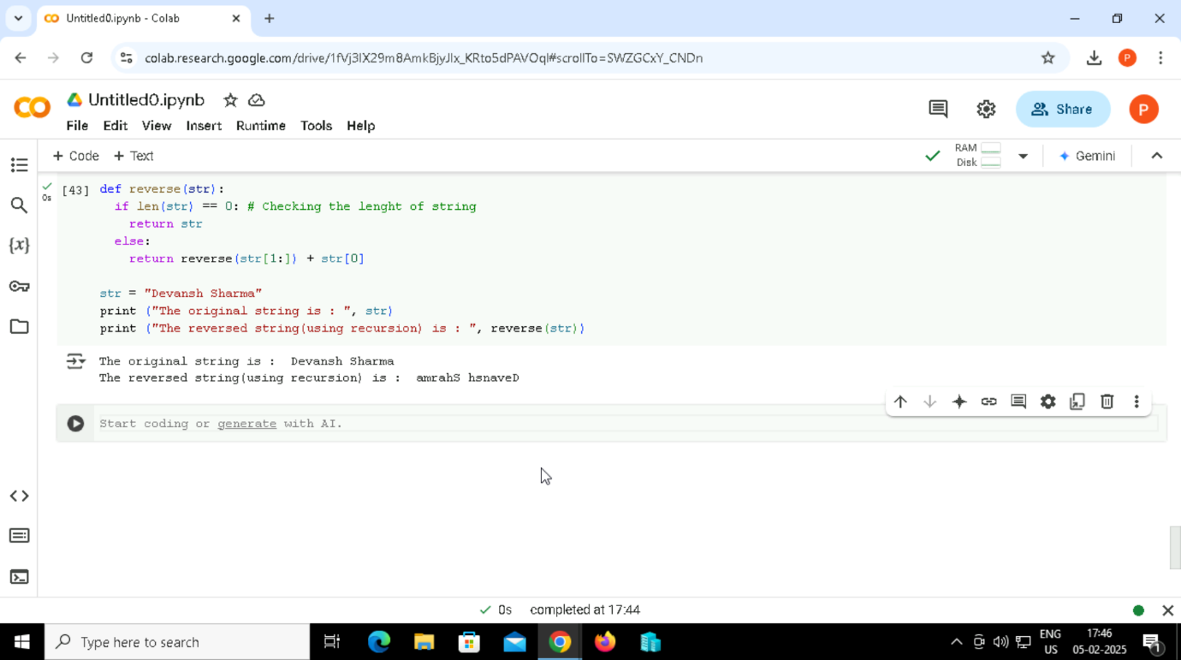

If Statement

14. Program to find even number.

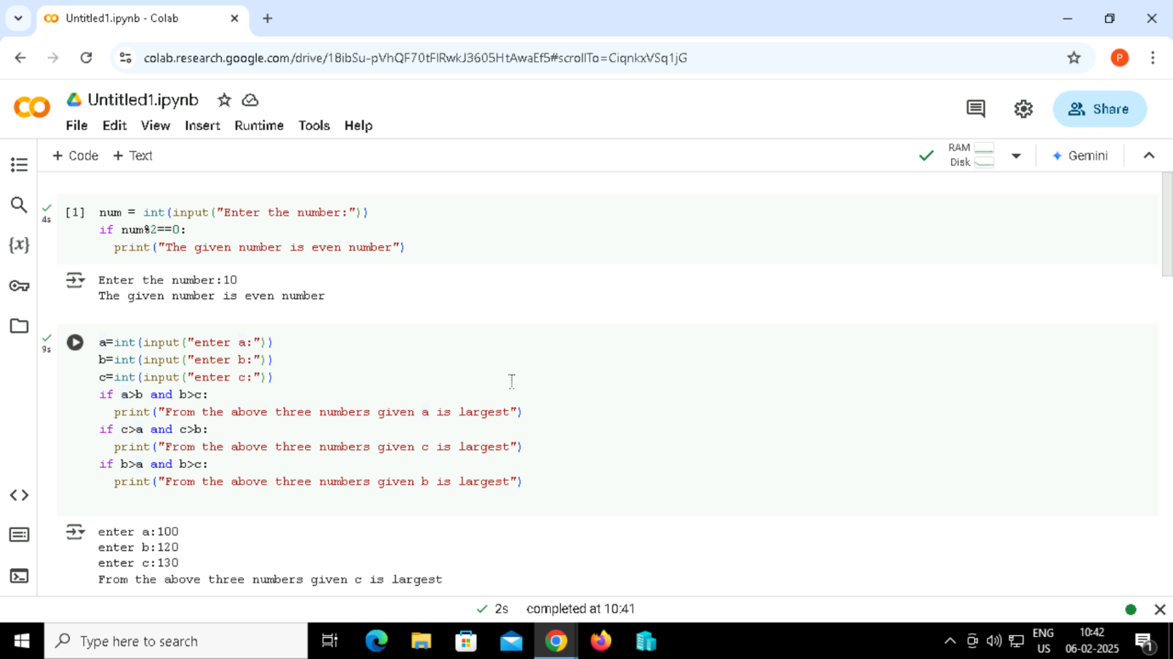

Output:

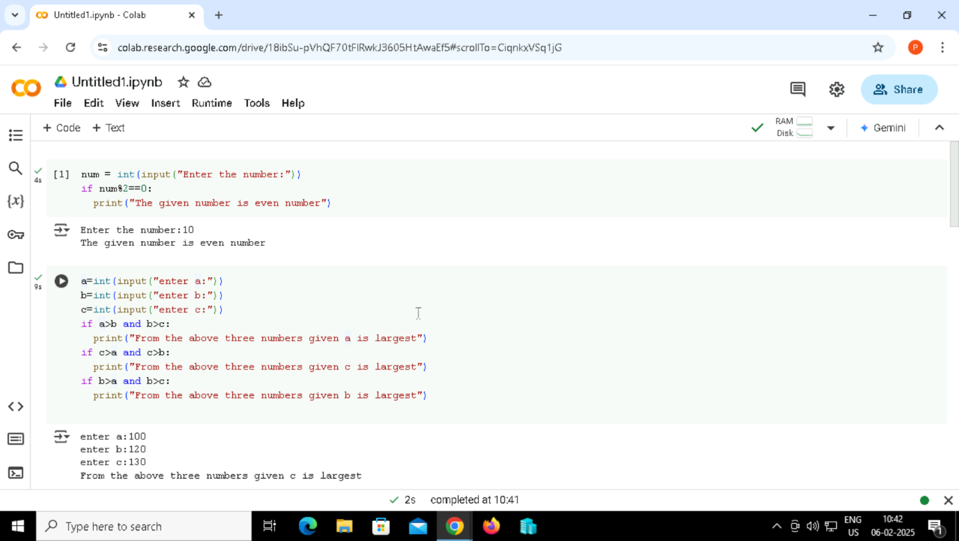

15. Program to print the largest of the three numbers.



Output:



If-else Statement

16.Program to check whether a person is eligible to vote or not.

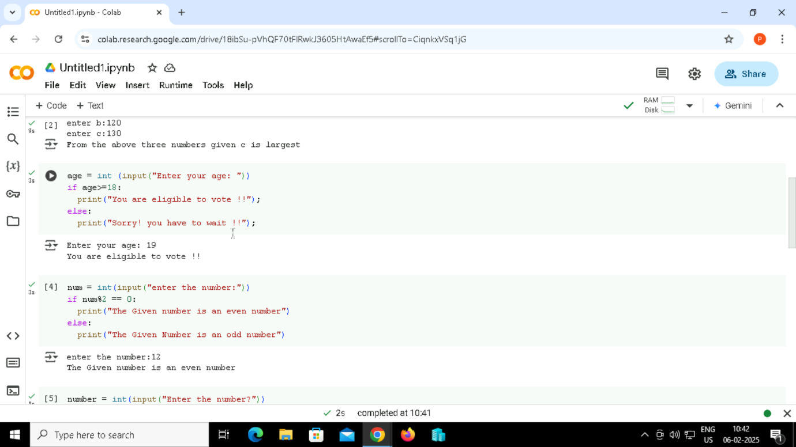

Output:

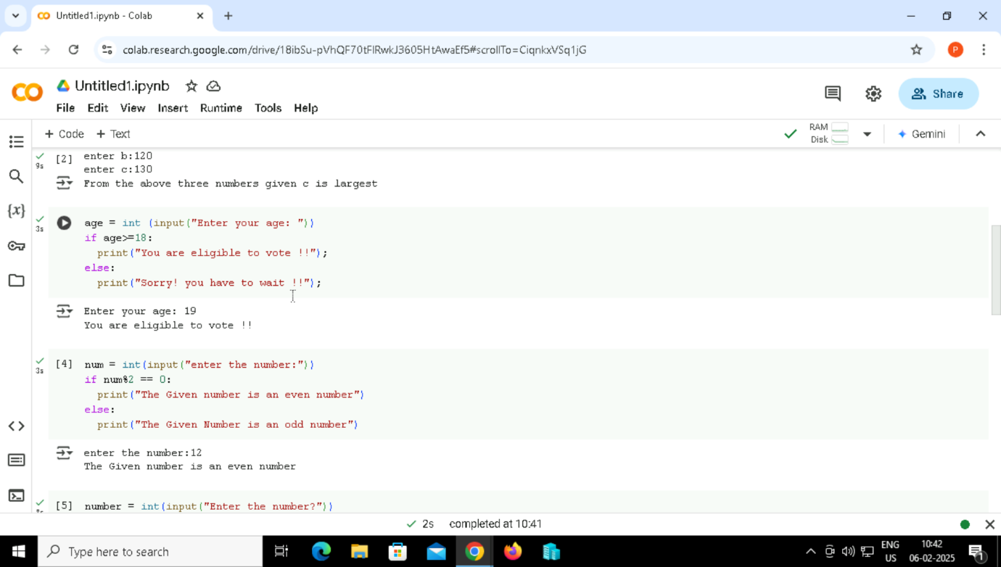

17. Program to check whether a number is even or not.



Output:



Elif Statement

18. Program to check whether a number is equal to 10, 50 or 100 or not.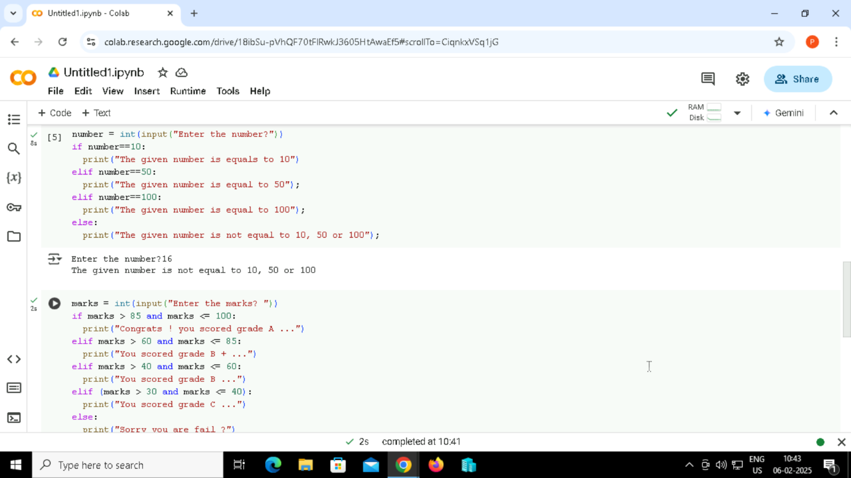

Output:



19. Program to check the grade of the student.

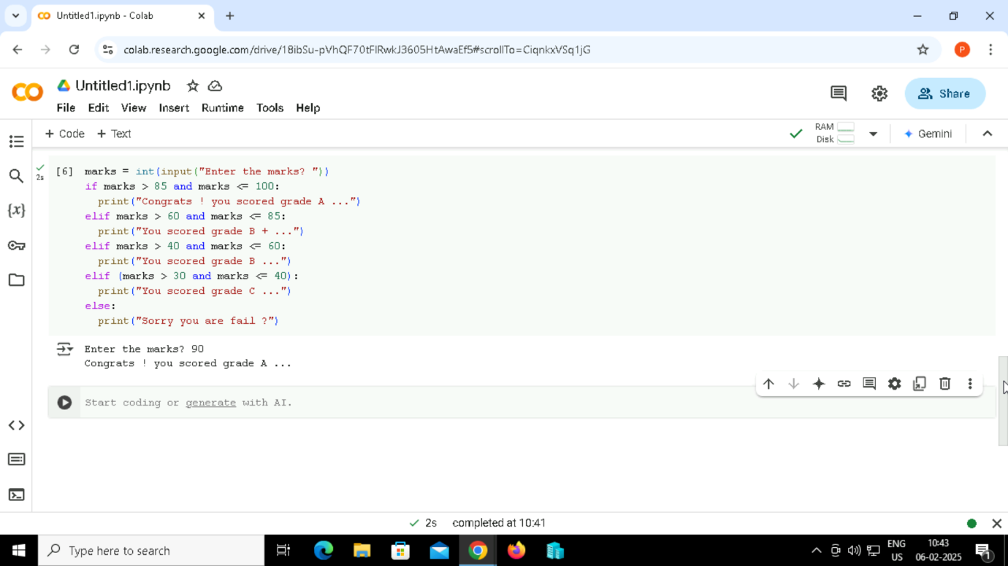

Output:



20.

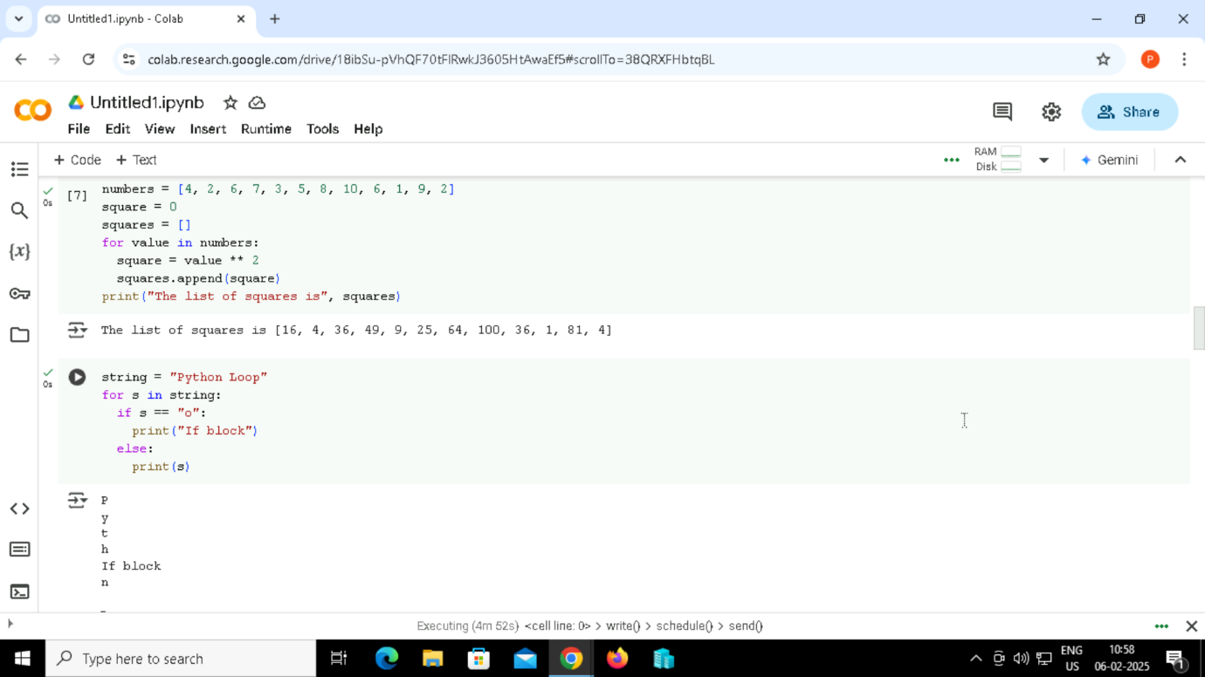

Output:

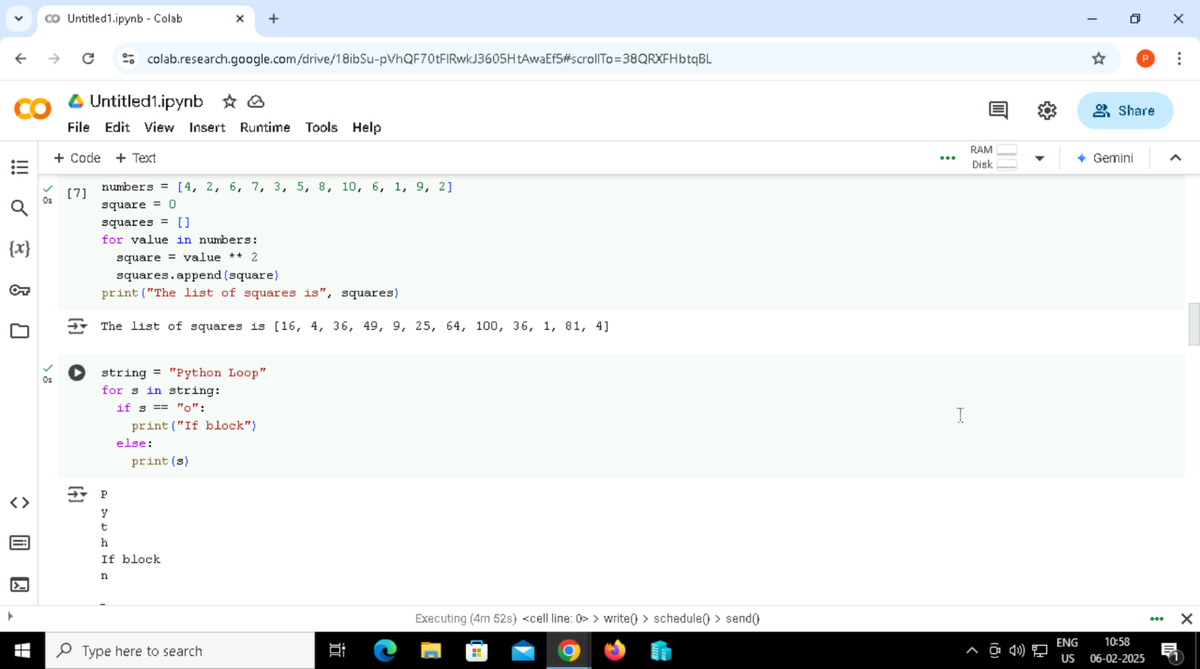

21. For Loop

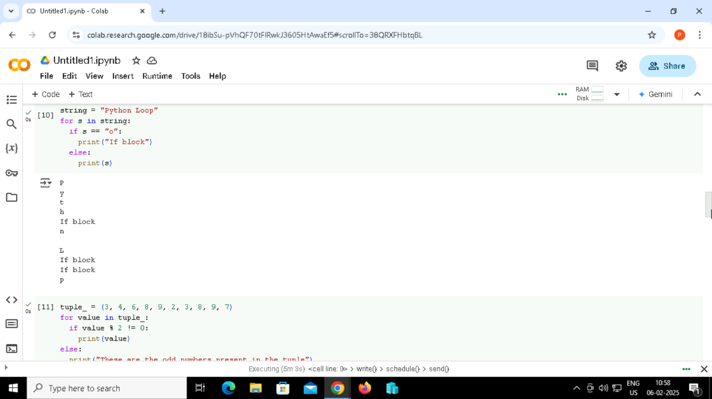

Output:

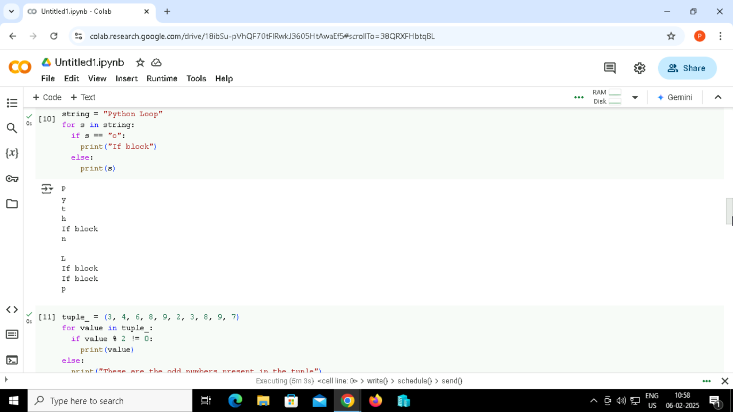

22. Using else Statement with for Loop

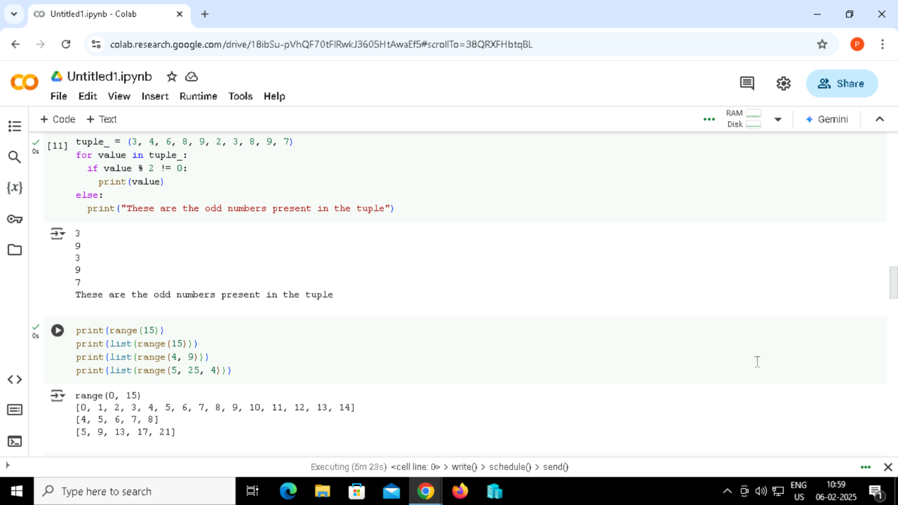

Output:



23. Program to show the working of range() function



Output:



24. Python program to iterate over a sequence with the help of indexing.

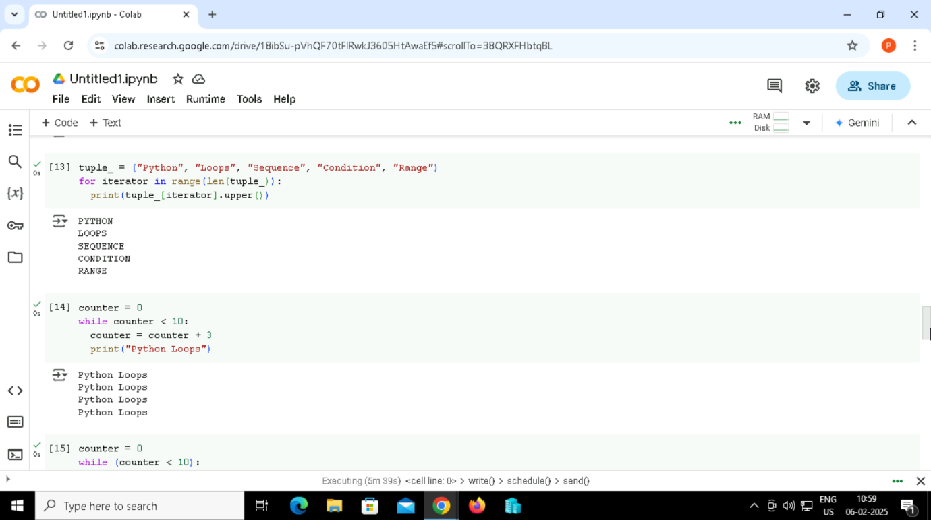

Output:

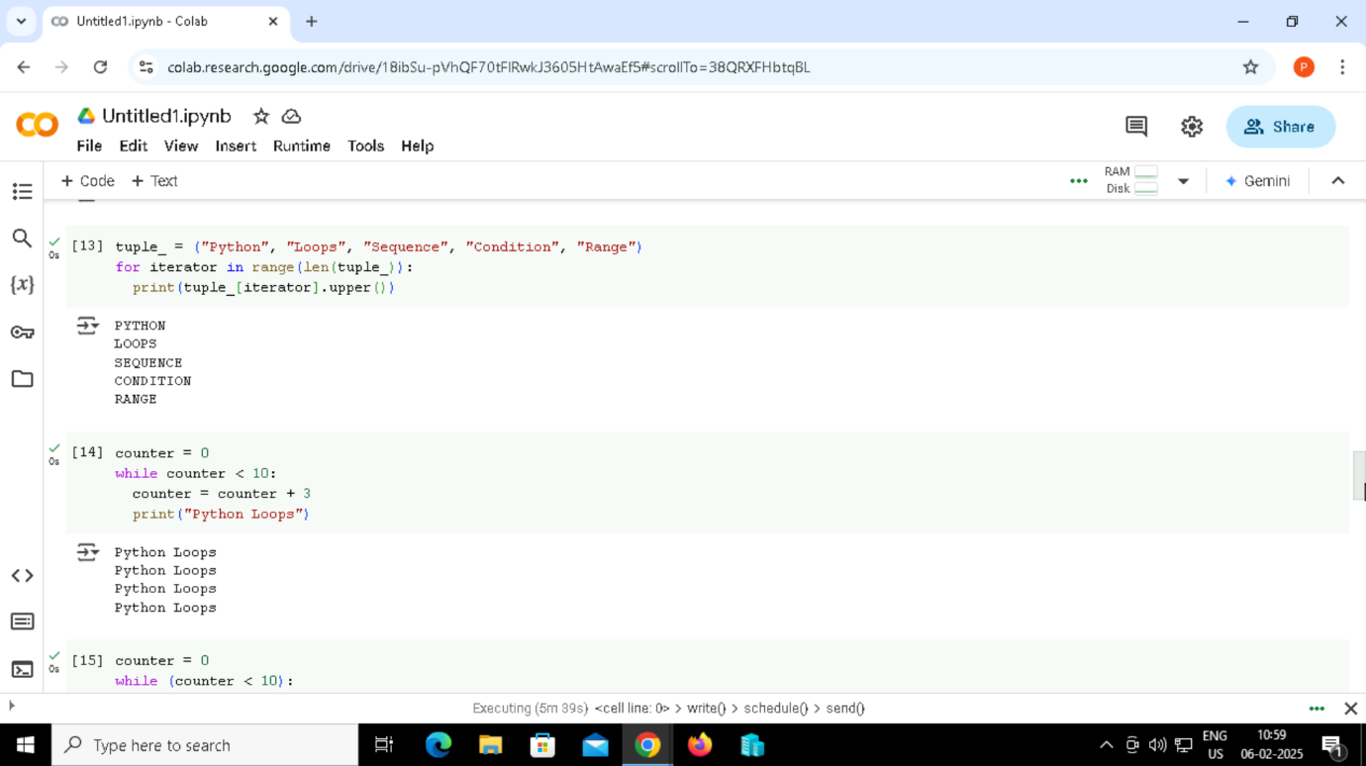

While Loop

25. Python program to show how to use a while loop

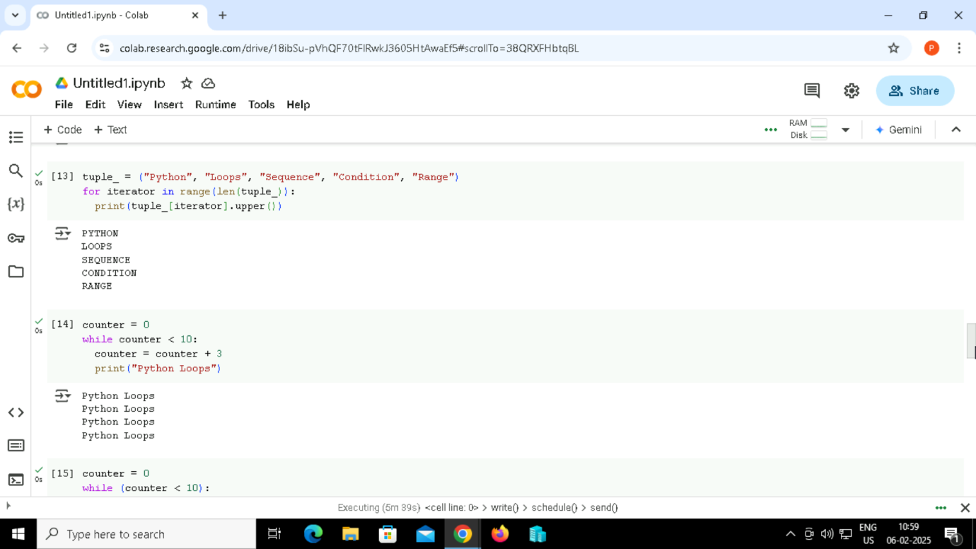

Output:



26. Python program to show how to use else statement with the while loop.

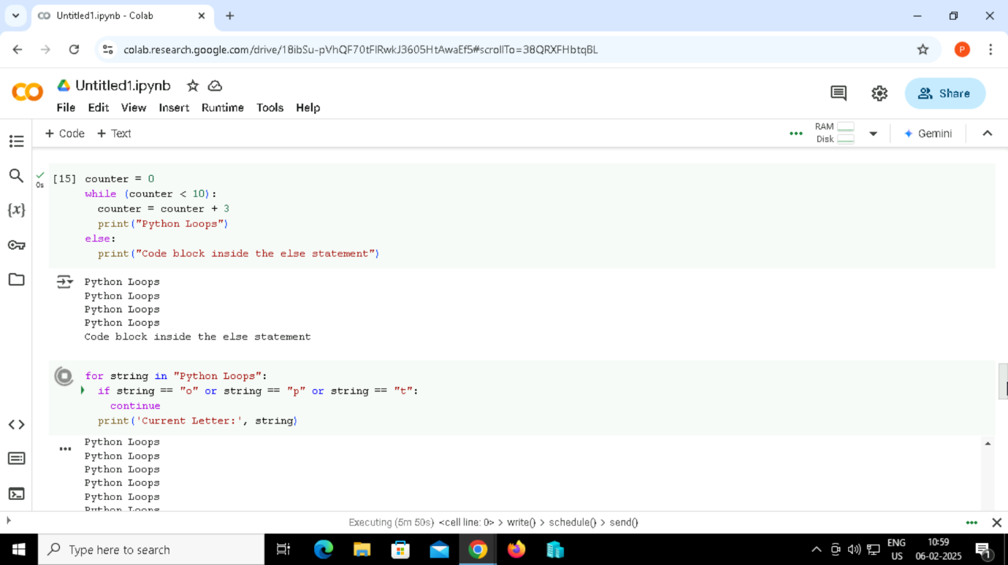

Output:

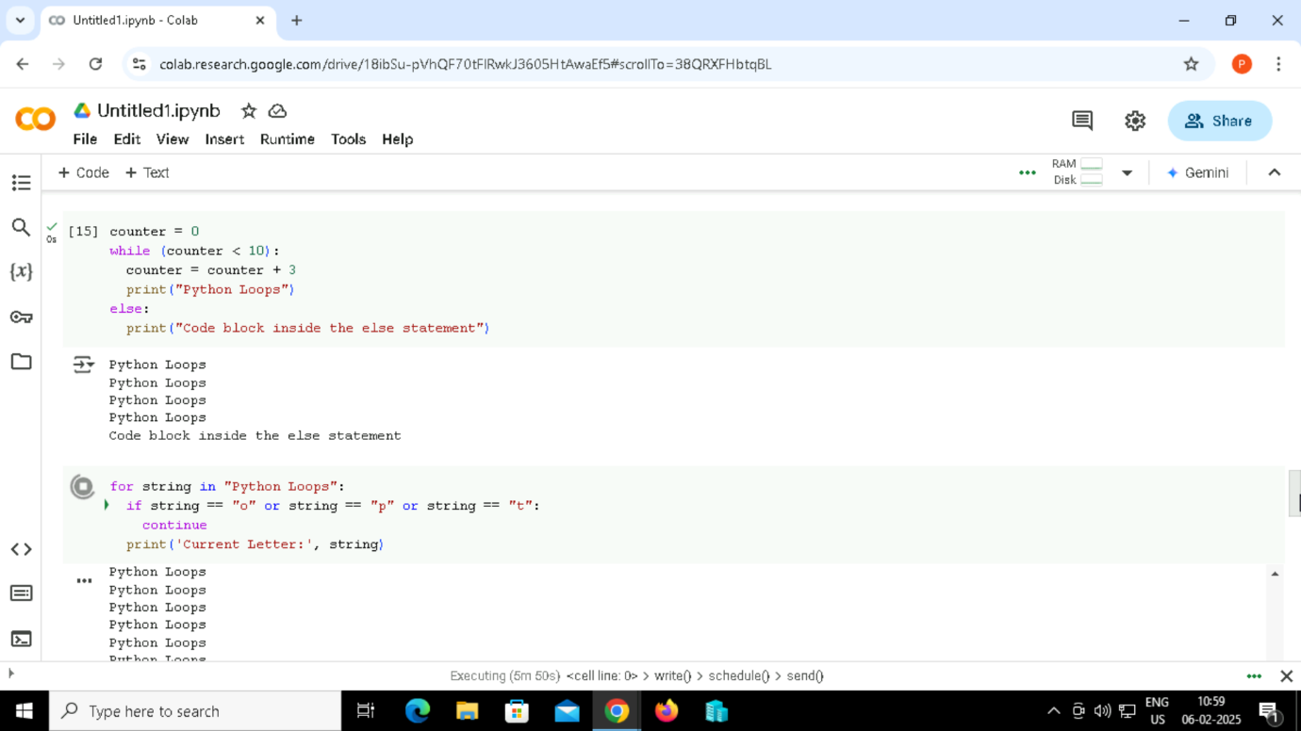

Continue Statement

27. Python program to show how the continue statement works

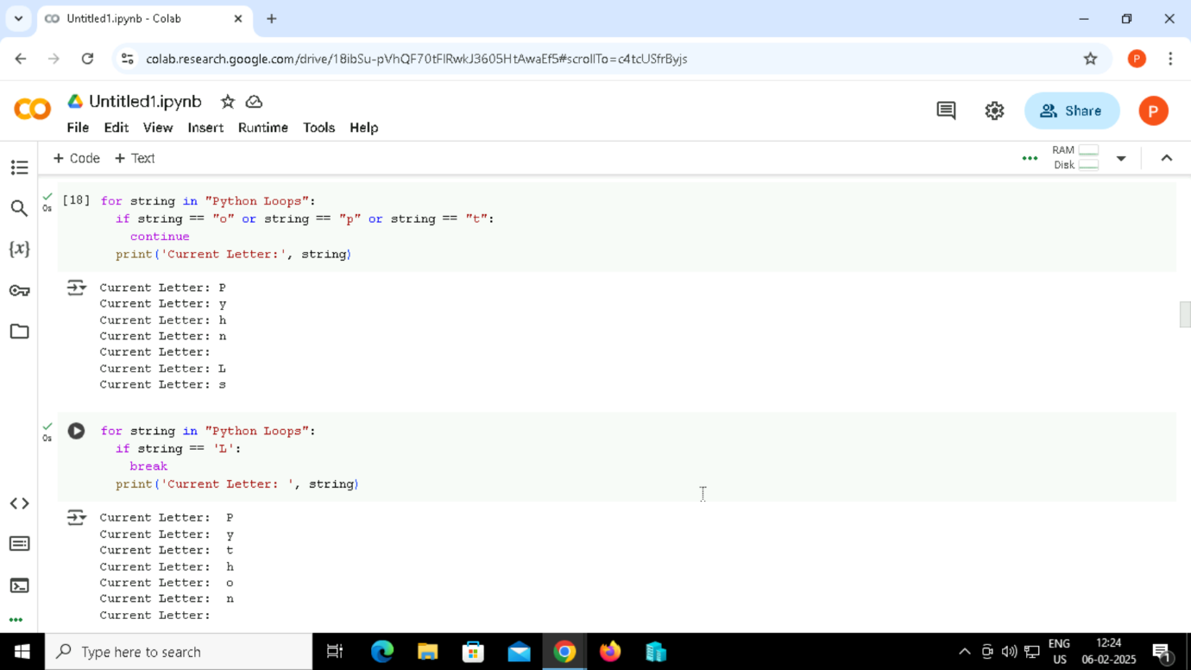

Output:

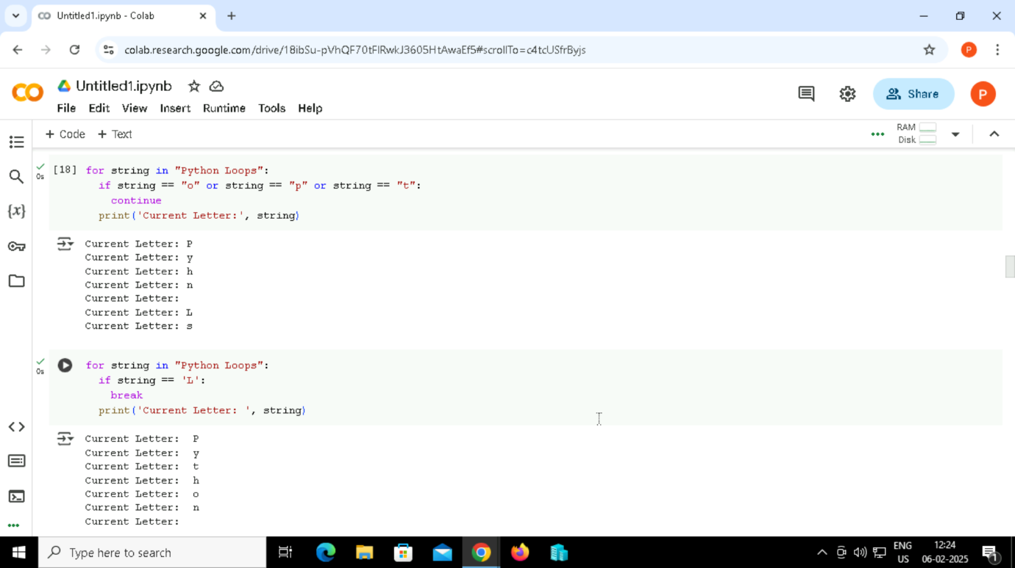

28. Break Statement

 Output:



29. Pass Statement

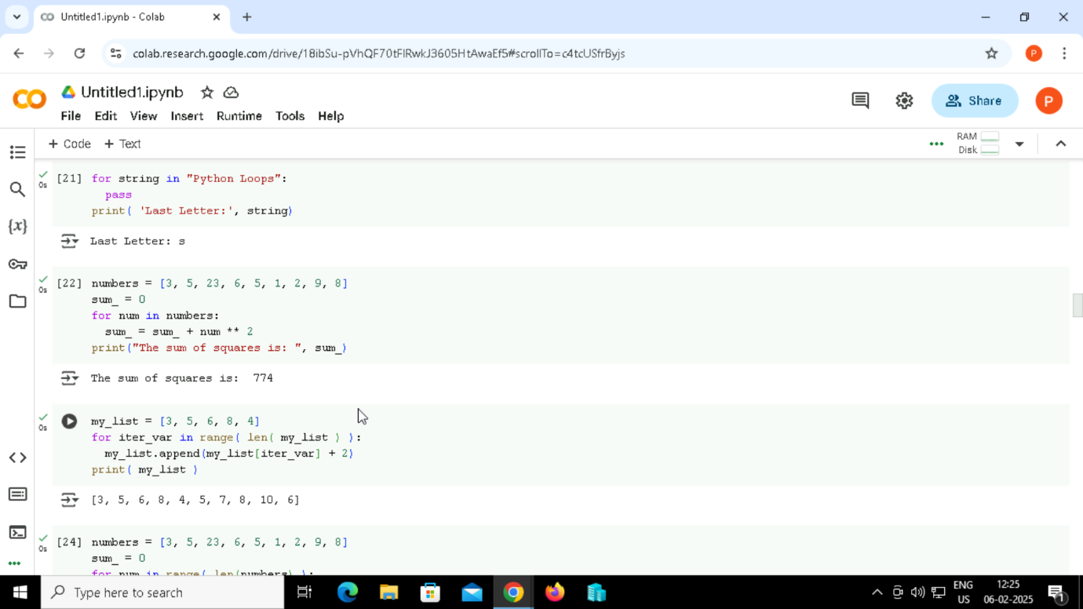

Output:

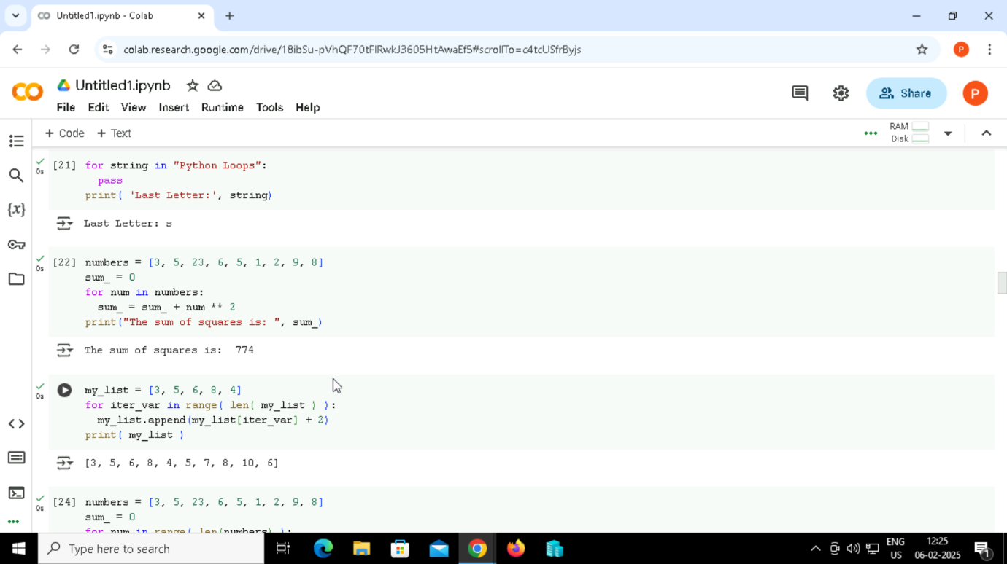

30. Code to find the sum of squares of each element of the list using for loop



Output:



31.range() function



Output:



32. Code to find the sum of squares of each element of the list using for loop.

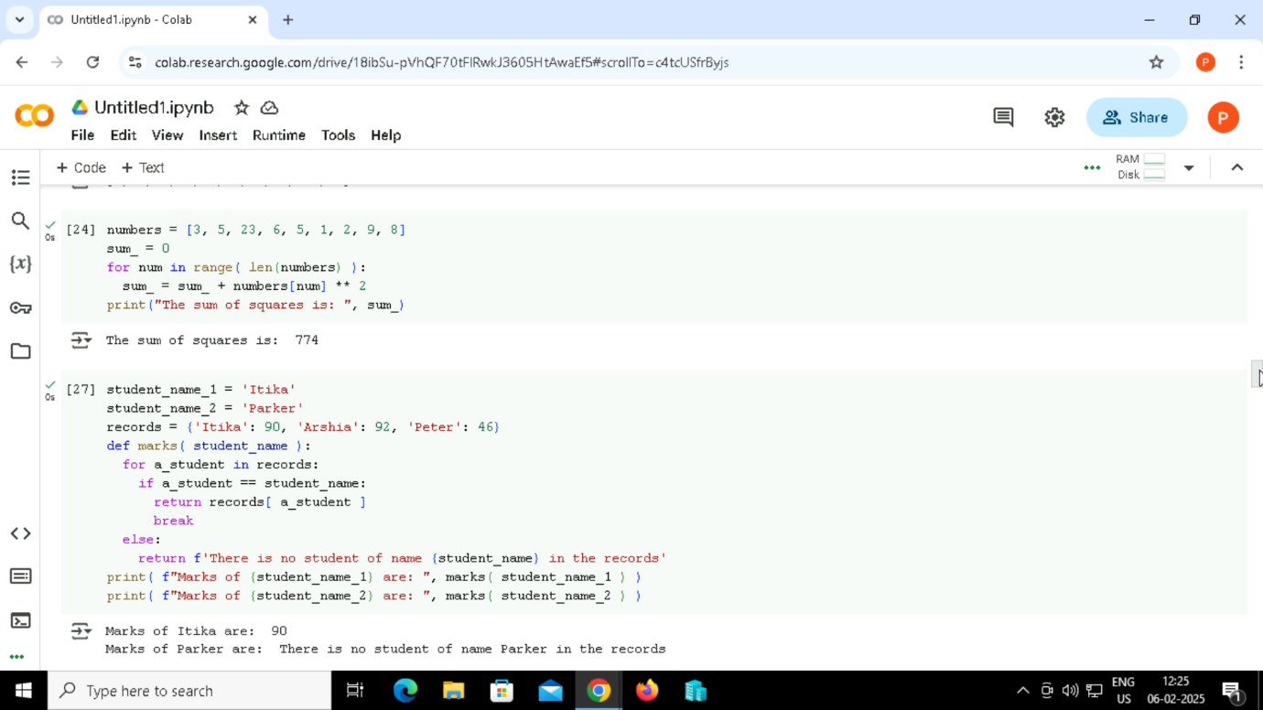

Output:



33. Code to print marks of a student from the record



Output:

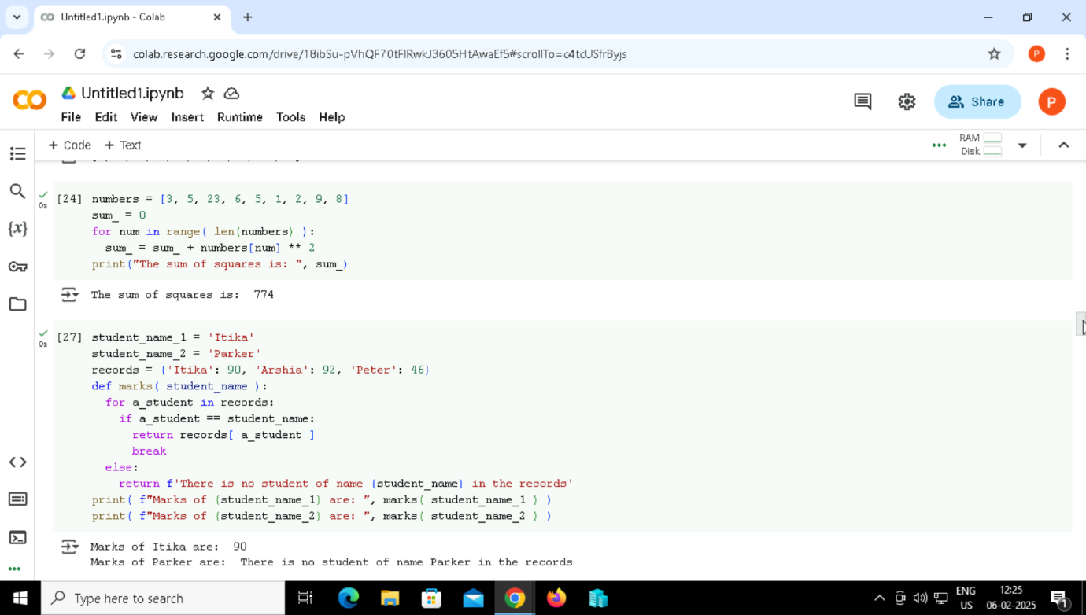

34. Nested Loops

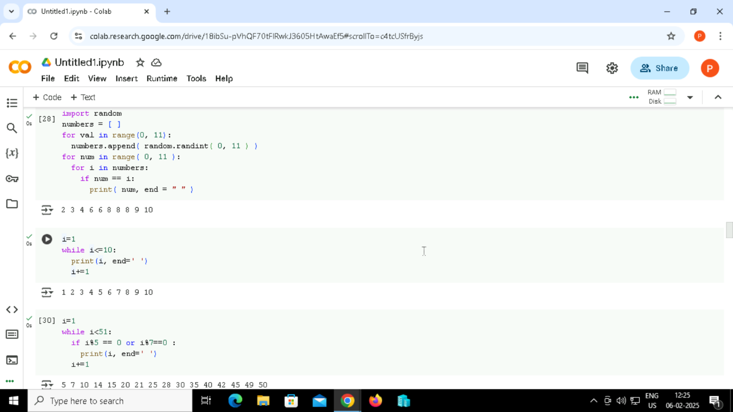

Output:

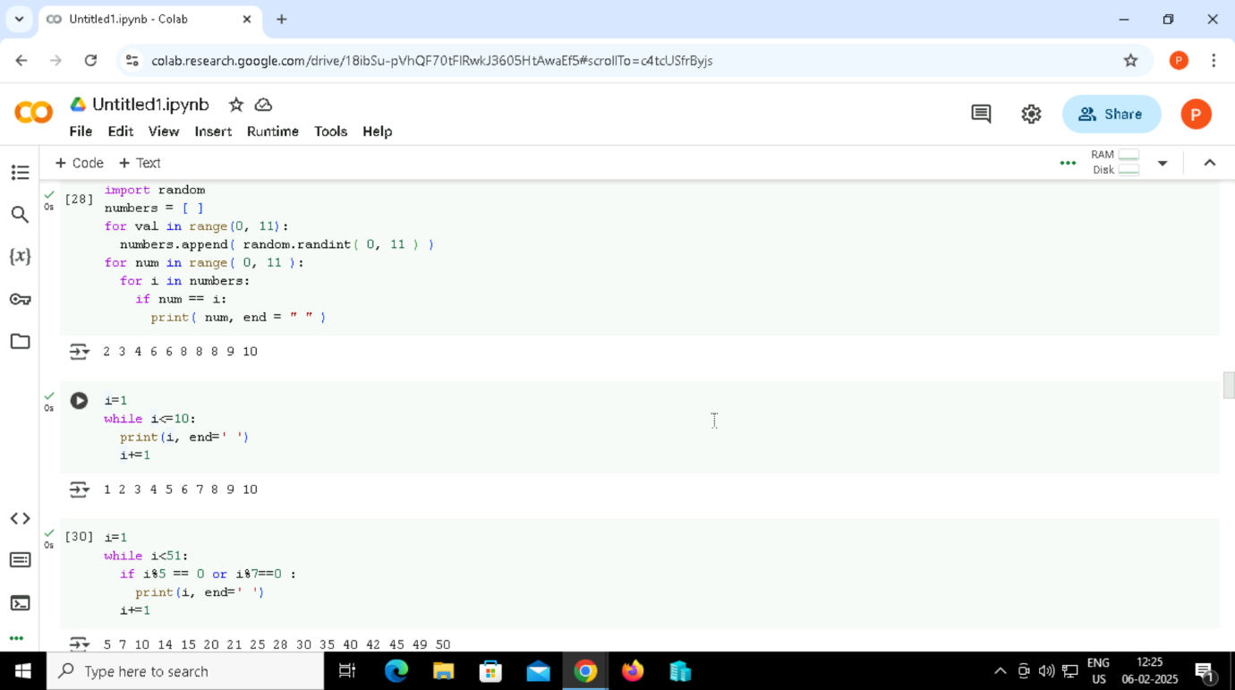

35. code examples of while loops in Python for printing numbers from 1 to 10.



Output:

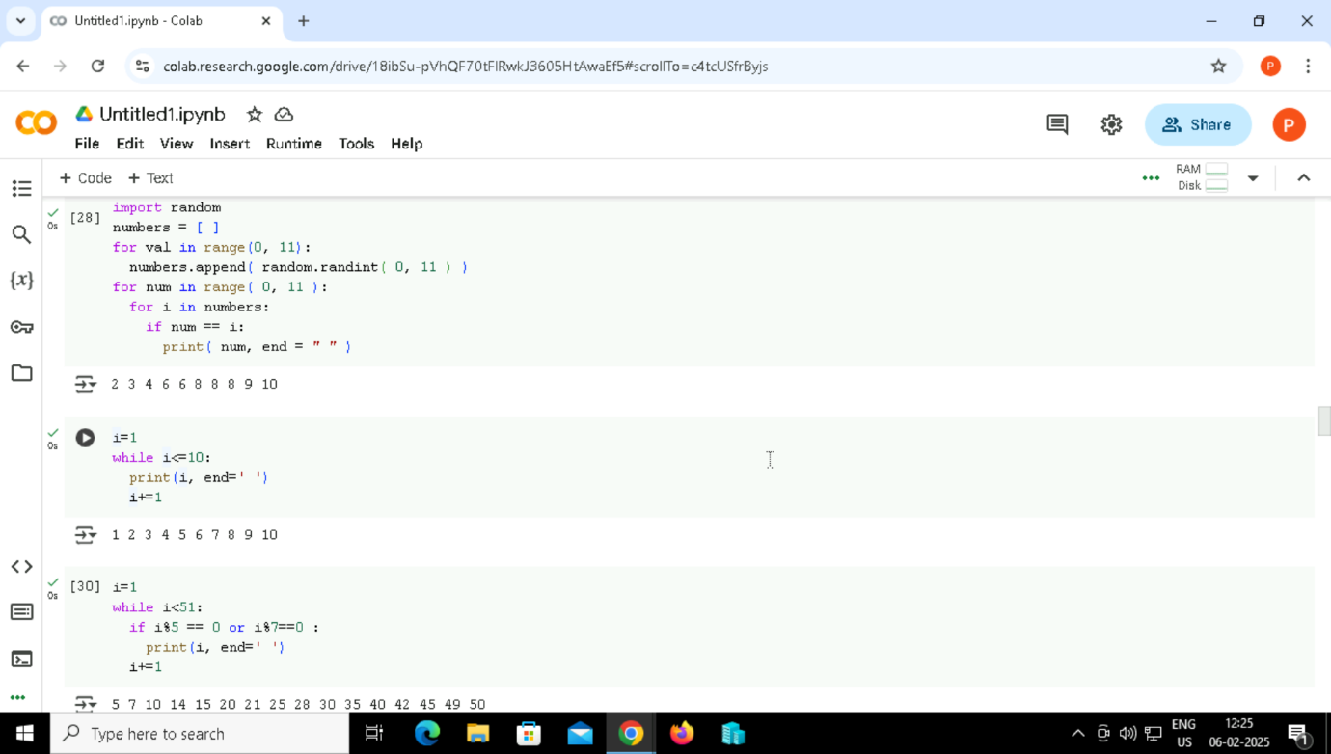

36. code examples of while loops in Python for Printing those numbers divisible by either 5 or 7 within 1 to 50 using a while loop.

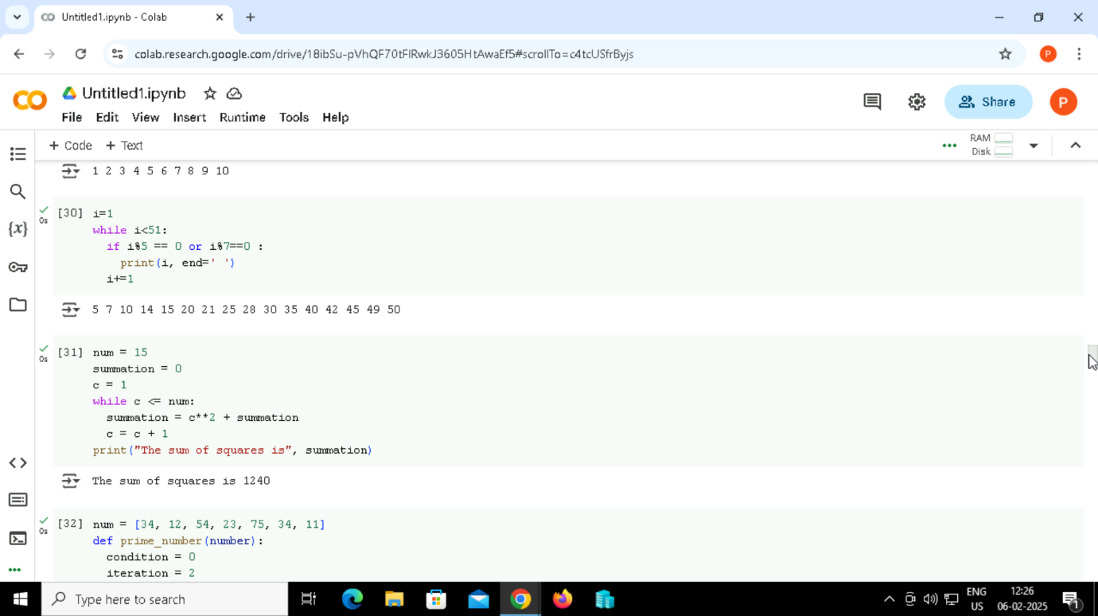

Output:

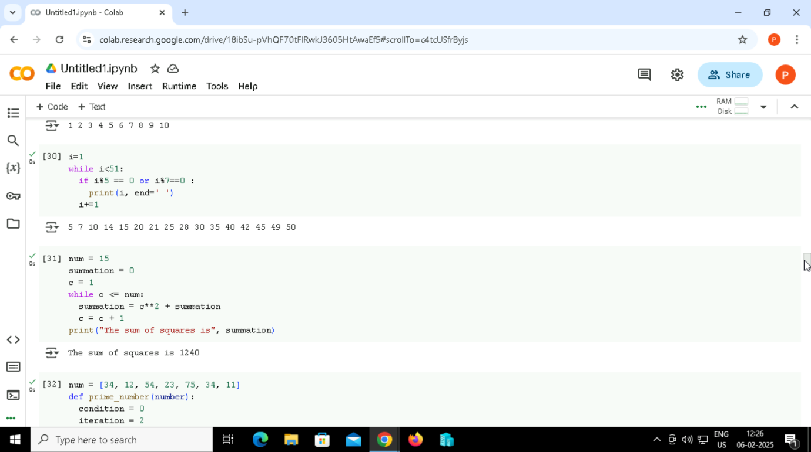

37. Code examples of while loops in Python, the sum of squares of the first 15 natural numbers using a while loop.

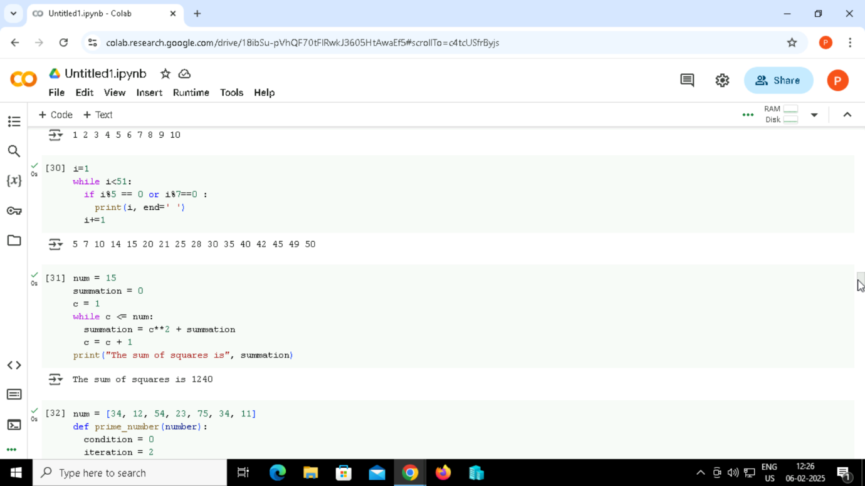

Output:



38. Code examples of while loops in Python for a number is Prime number or not.

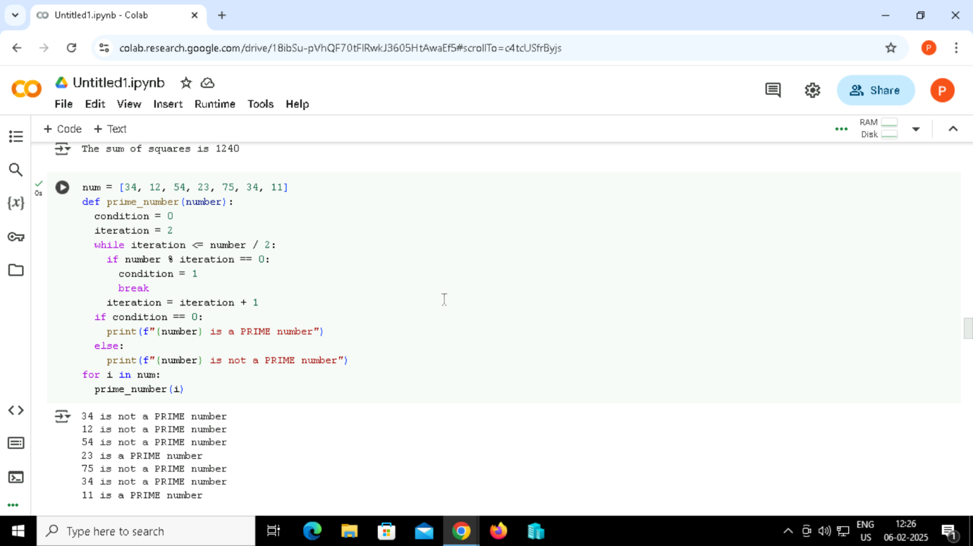

Output:



39. Program using a while loop to verify whether the given integer is an Armstrong number.

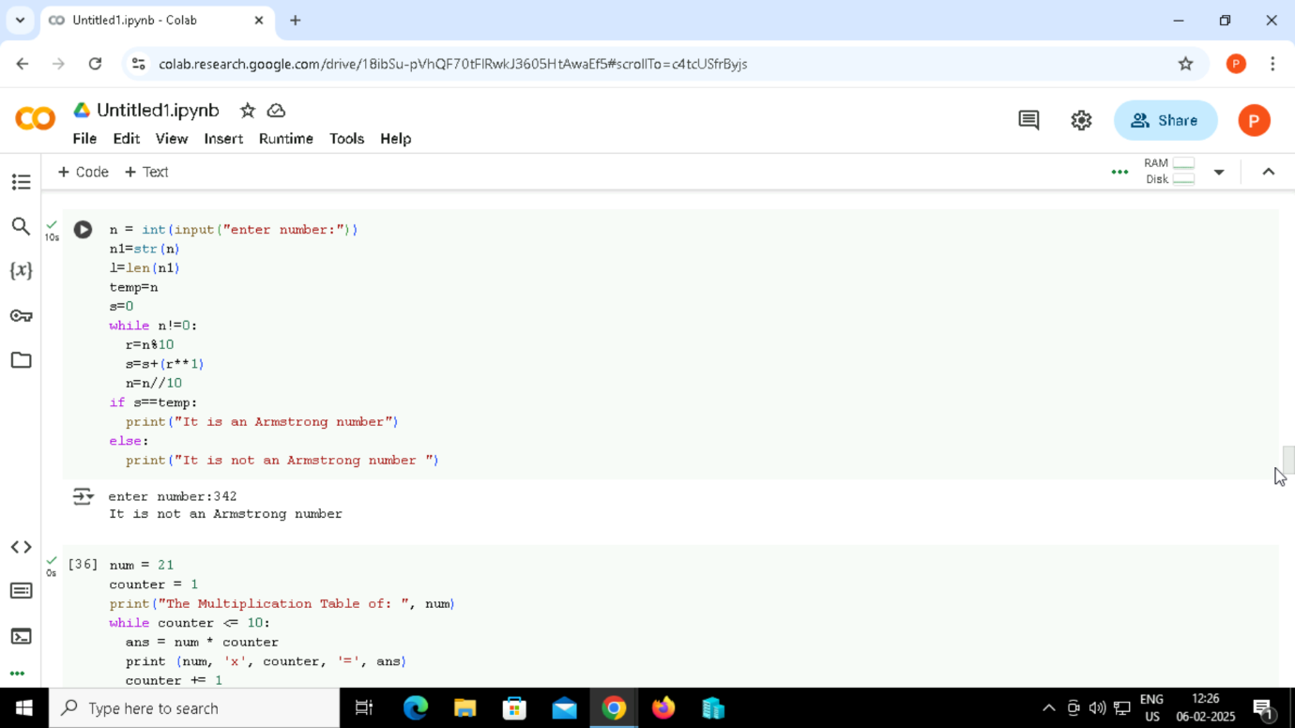

Output:

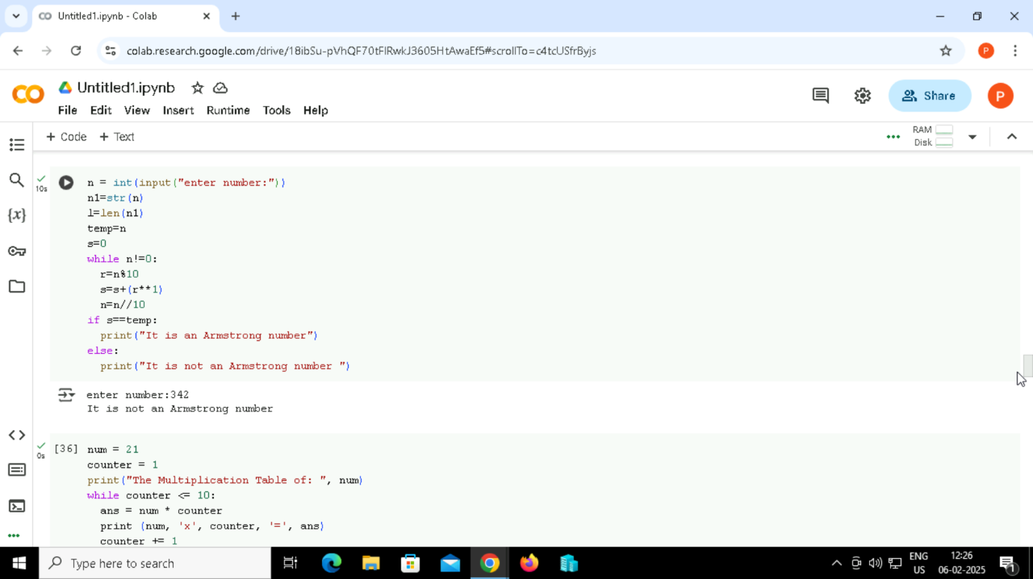

40. U se the while loop for printing the multiplication table of a given number.

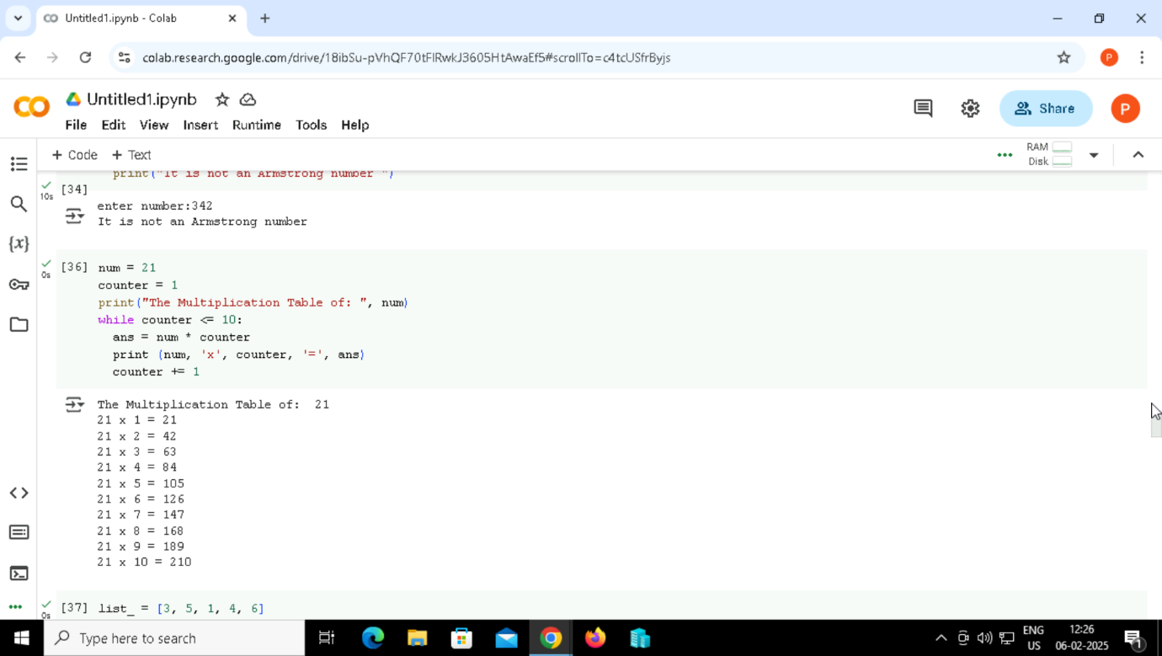

Output:

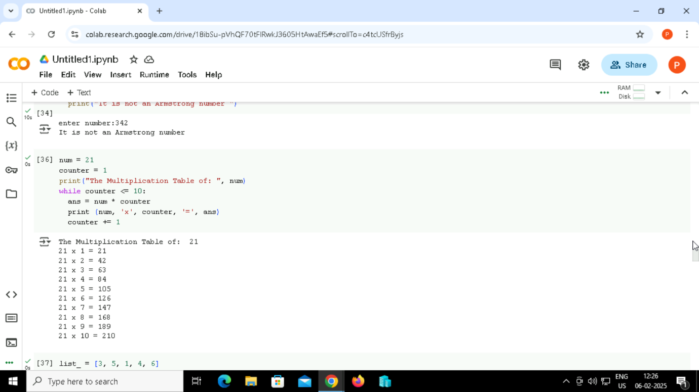

41.Code examples of while loops in Python for square every number of a list.

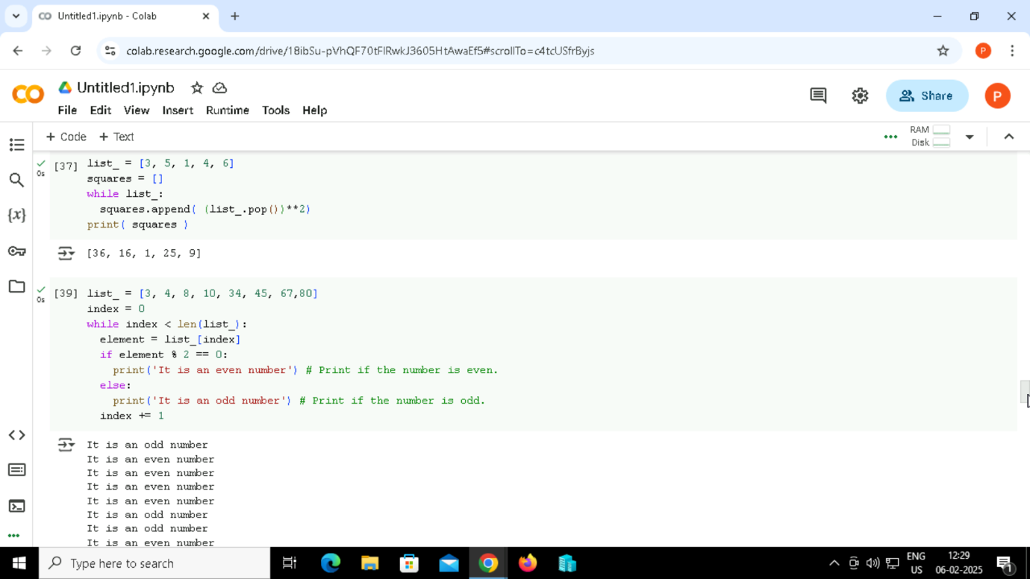

Output:



42. code examples of while loops in Python for determine odd and even number from every number of a list.

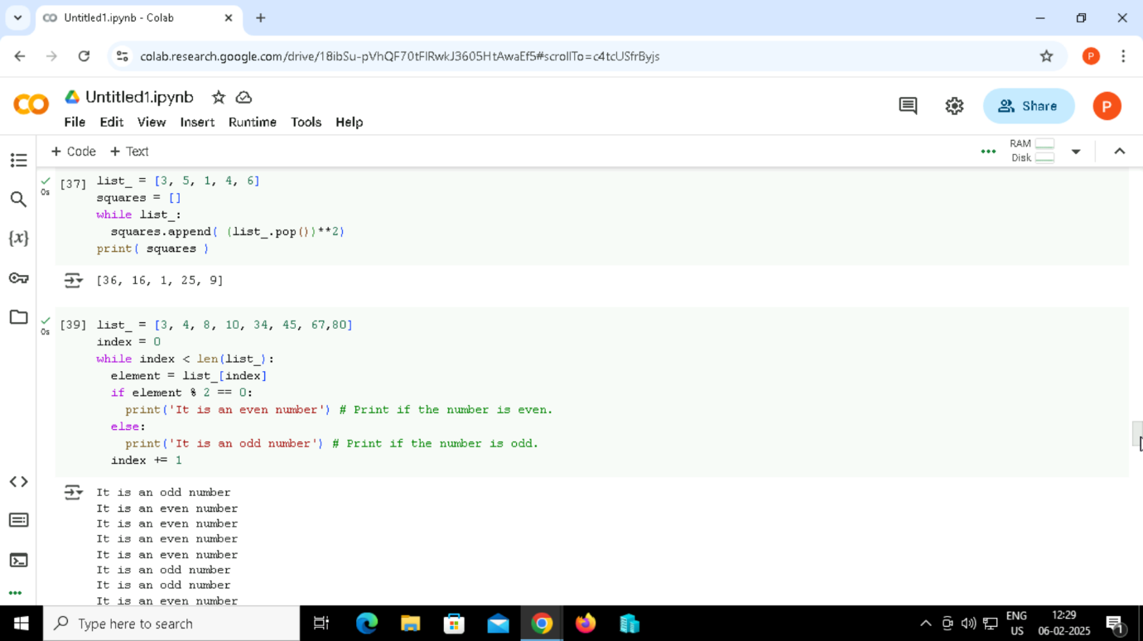

Output:



43. code examples of while loops in Python for determine the number letters of every word from the given list.

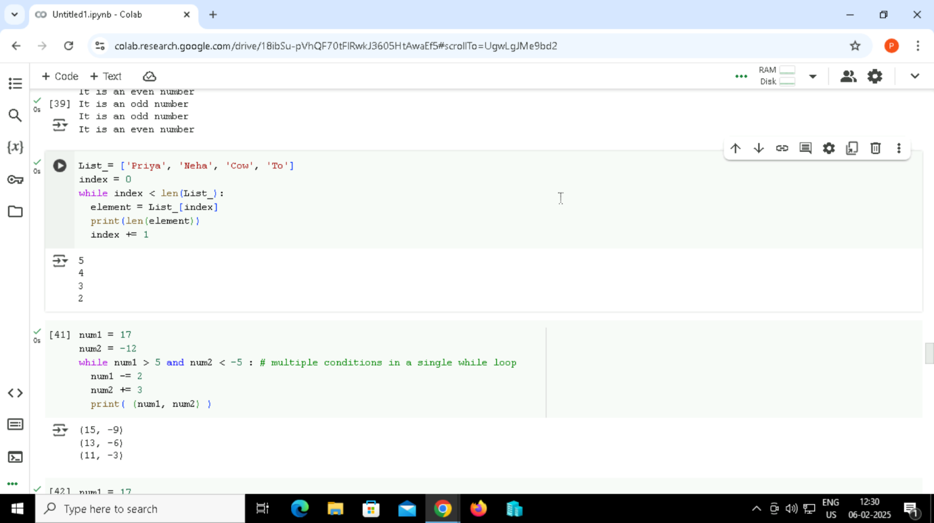

Output:

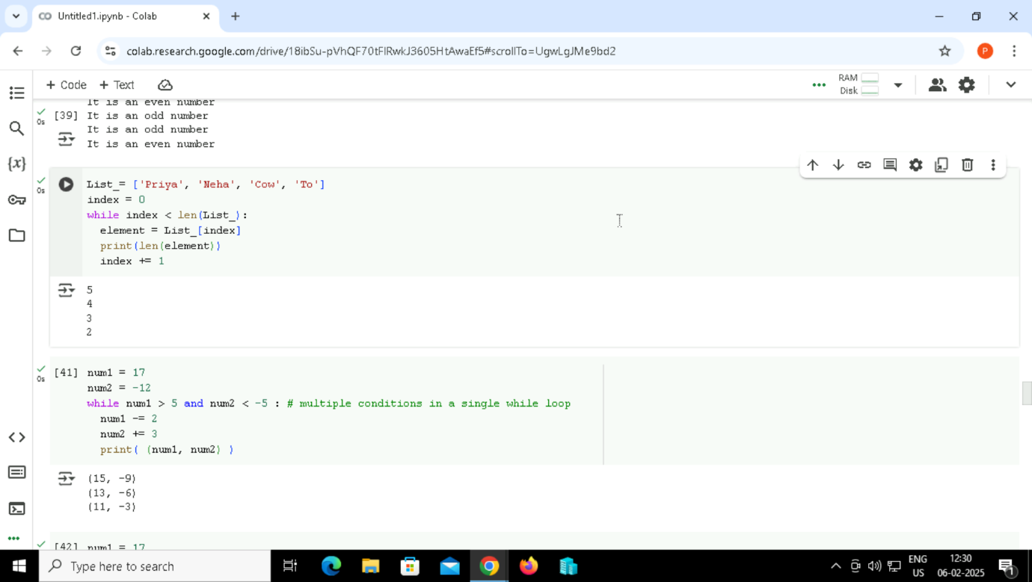

44. code examples of while loops in Python for multiple condition.

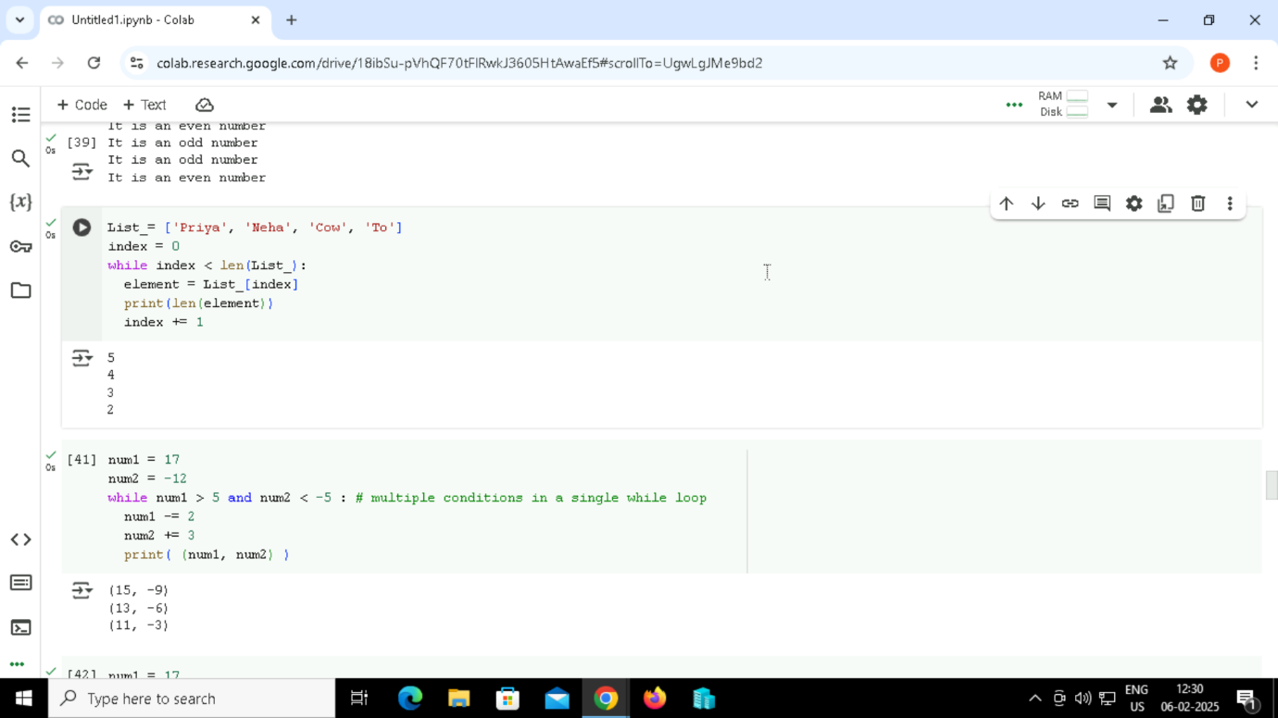

Output:



45. another example of multiple conditions with an OR operator.

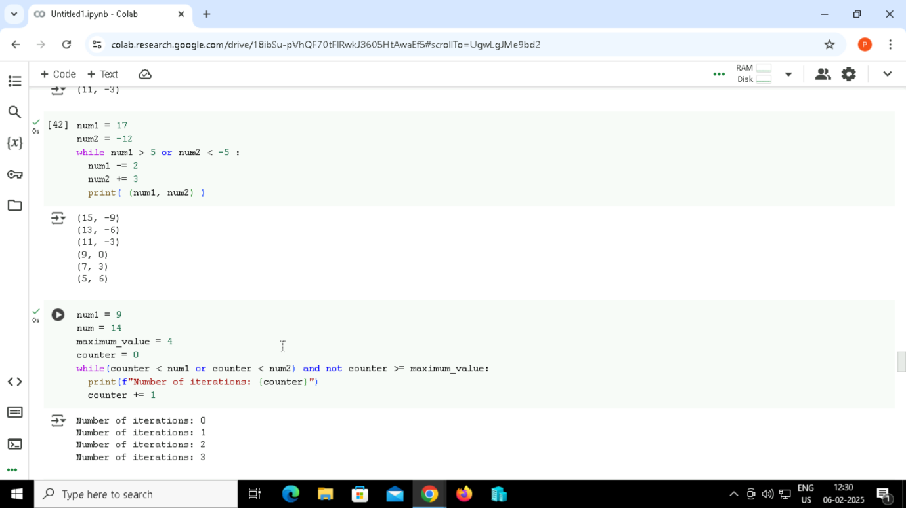

Output:



46.



Output:

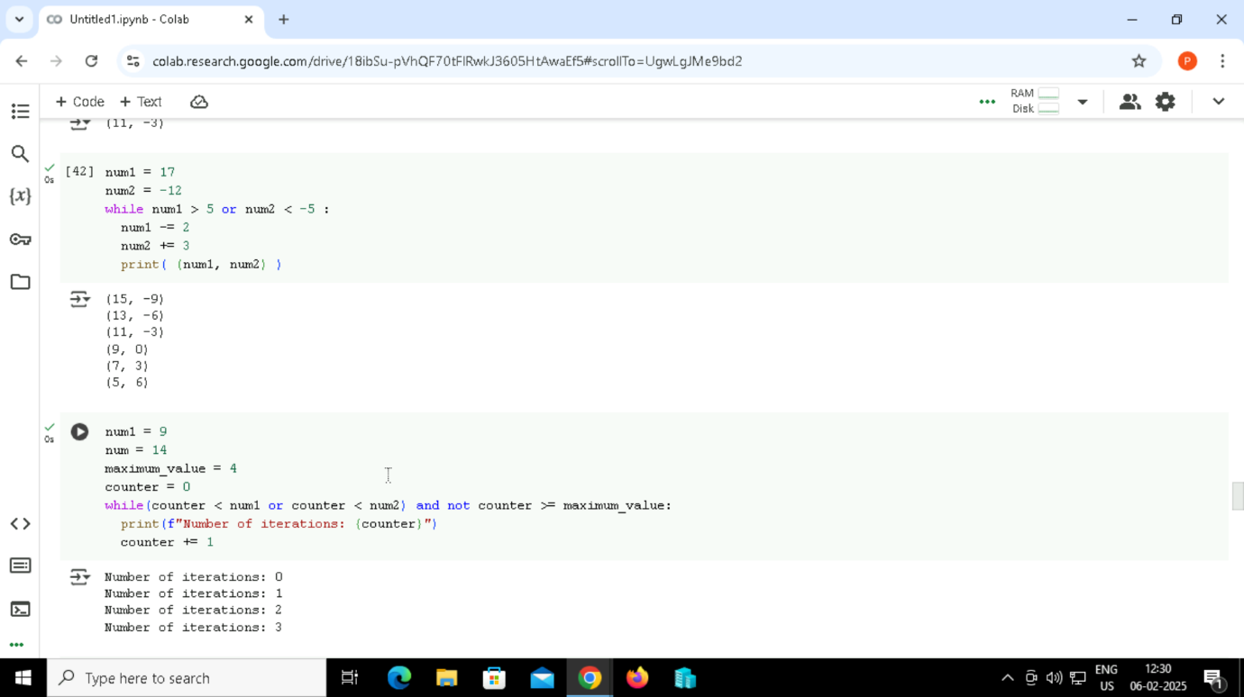

47. Continue Statement

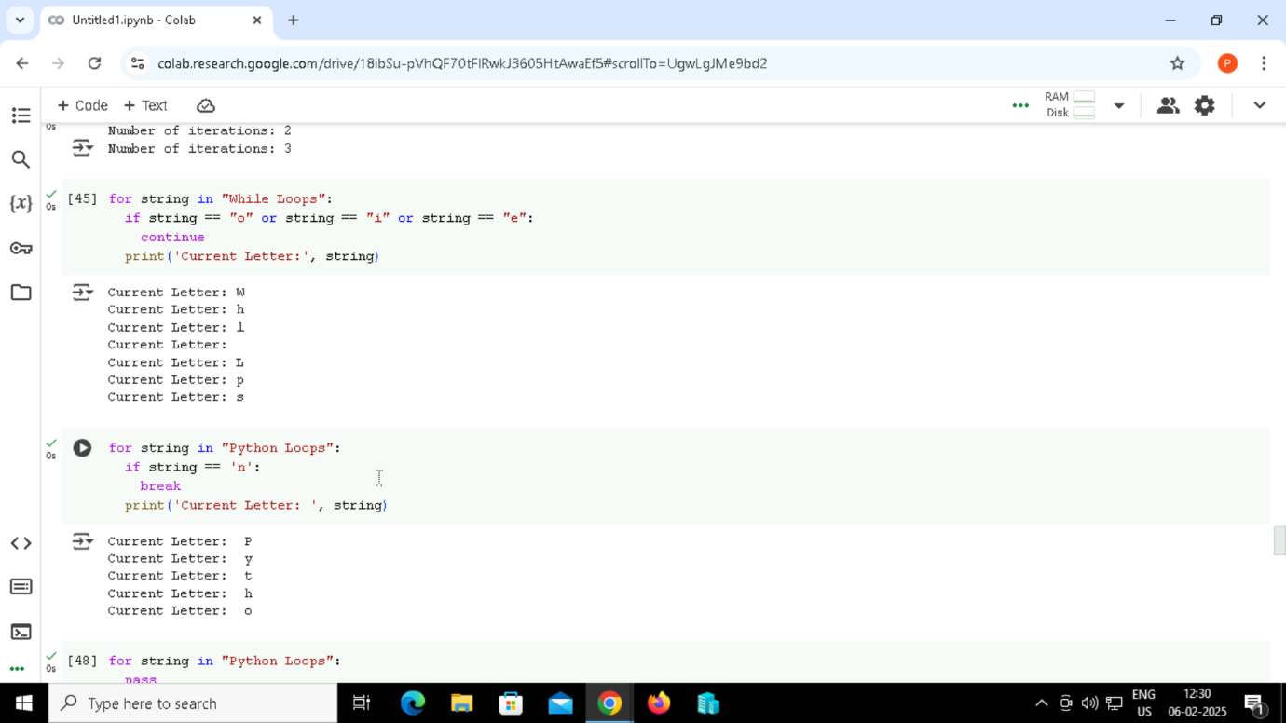

Output:



48. Break Statement



Output:



49. Pass Statement

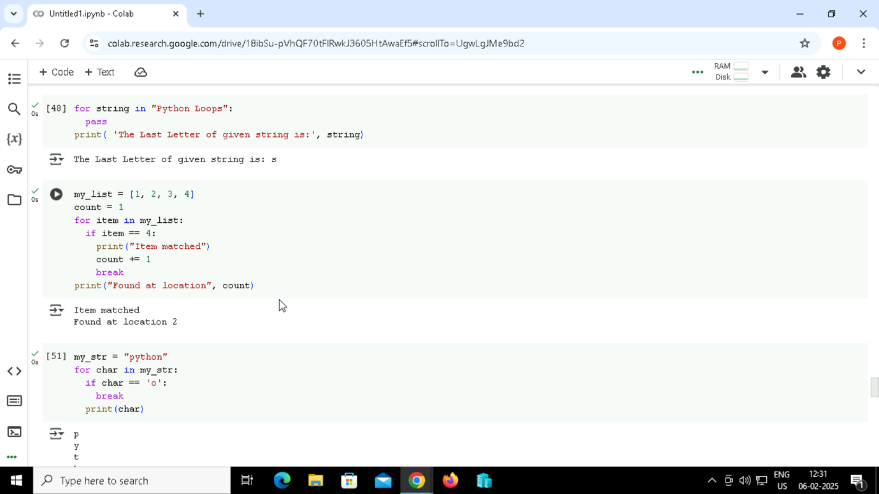

Output:

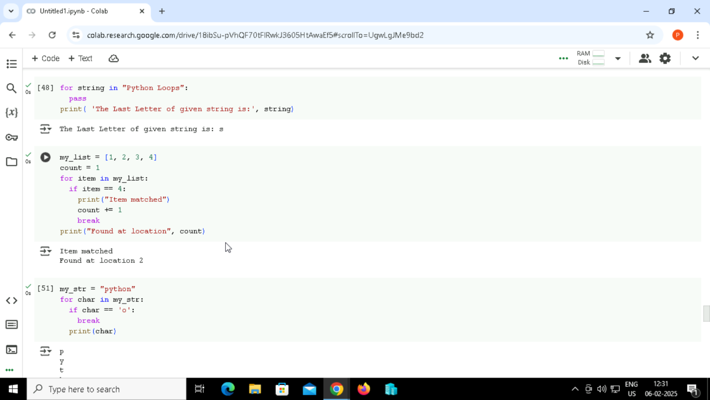

50. break statement with for loop



Output:



51. Breaking out of a loop early

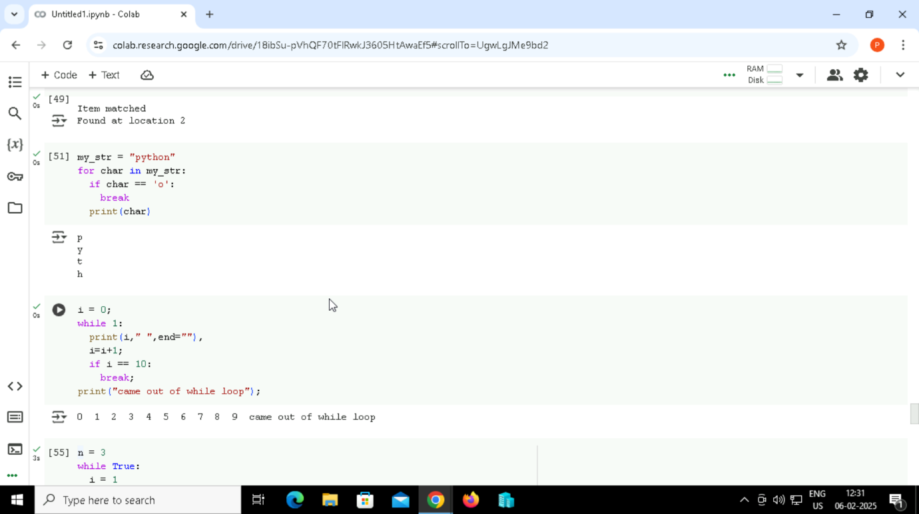

Output:

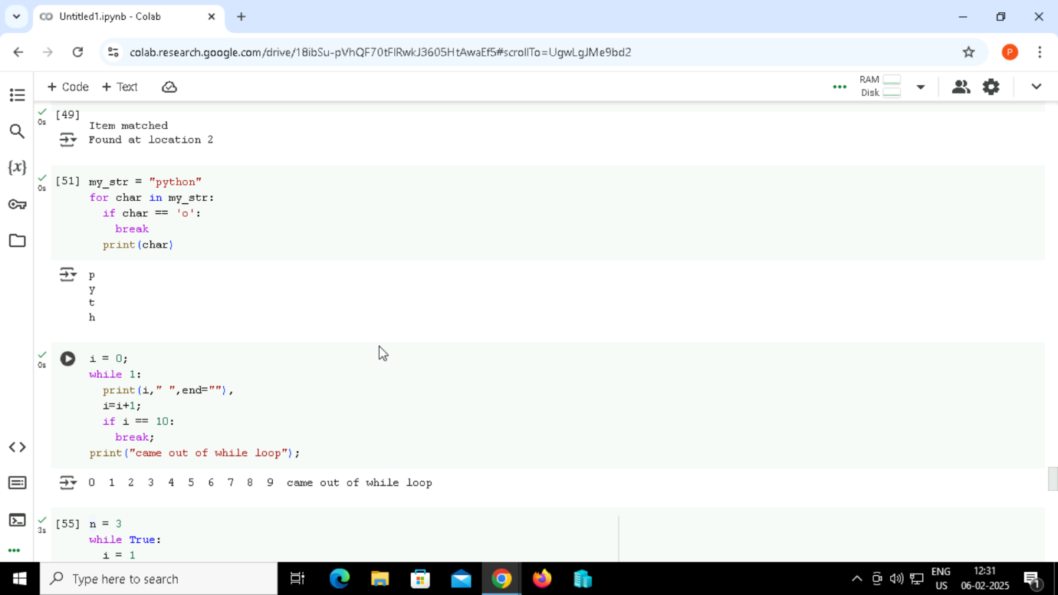

52. break statement with while loop



Output:

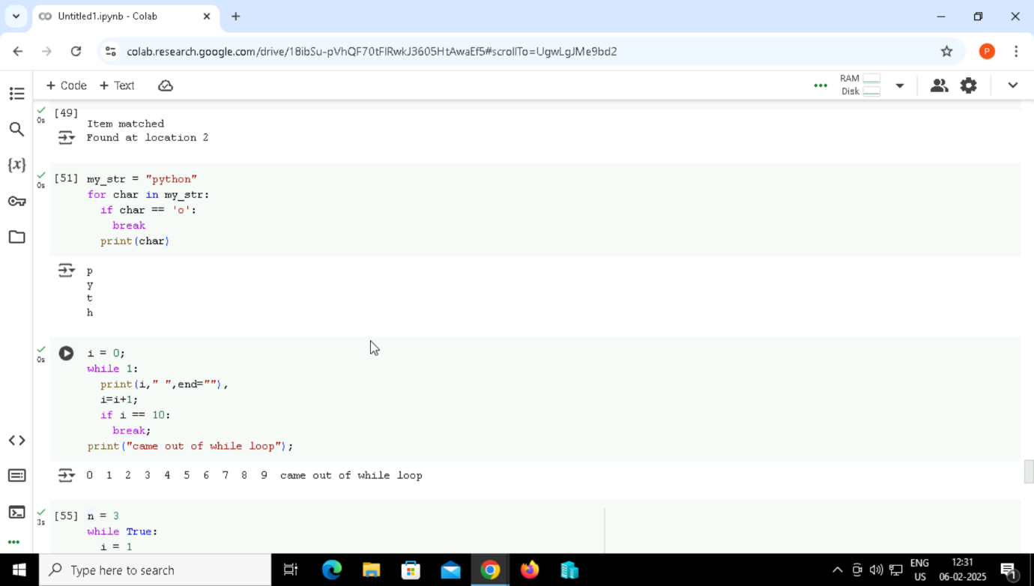

53. break statement with nested loop

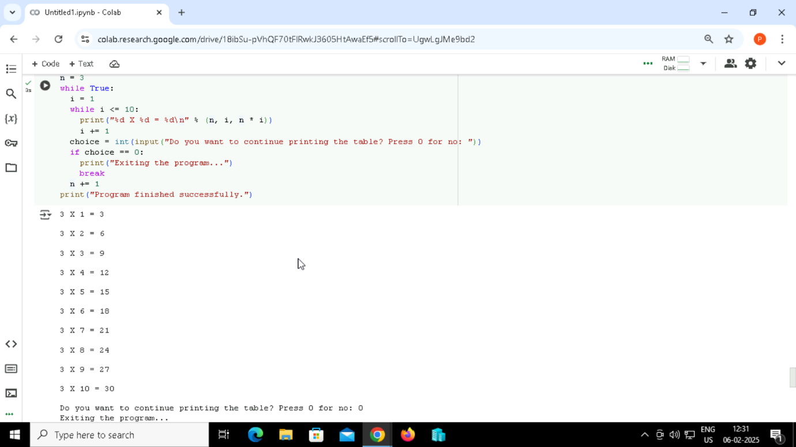

Output:



54. Python Continue Statements in while Loop

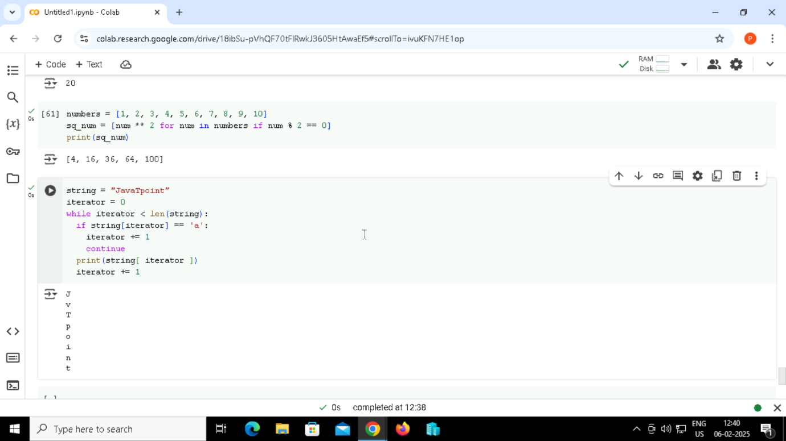

Output:



55. Python Continue statement in list comprehension

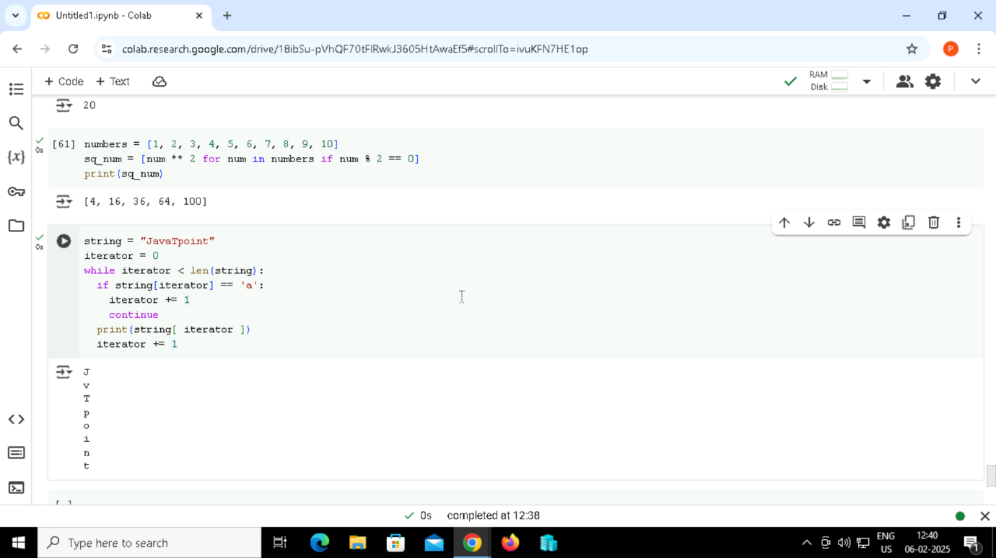

Output:

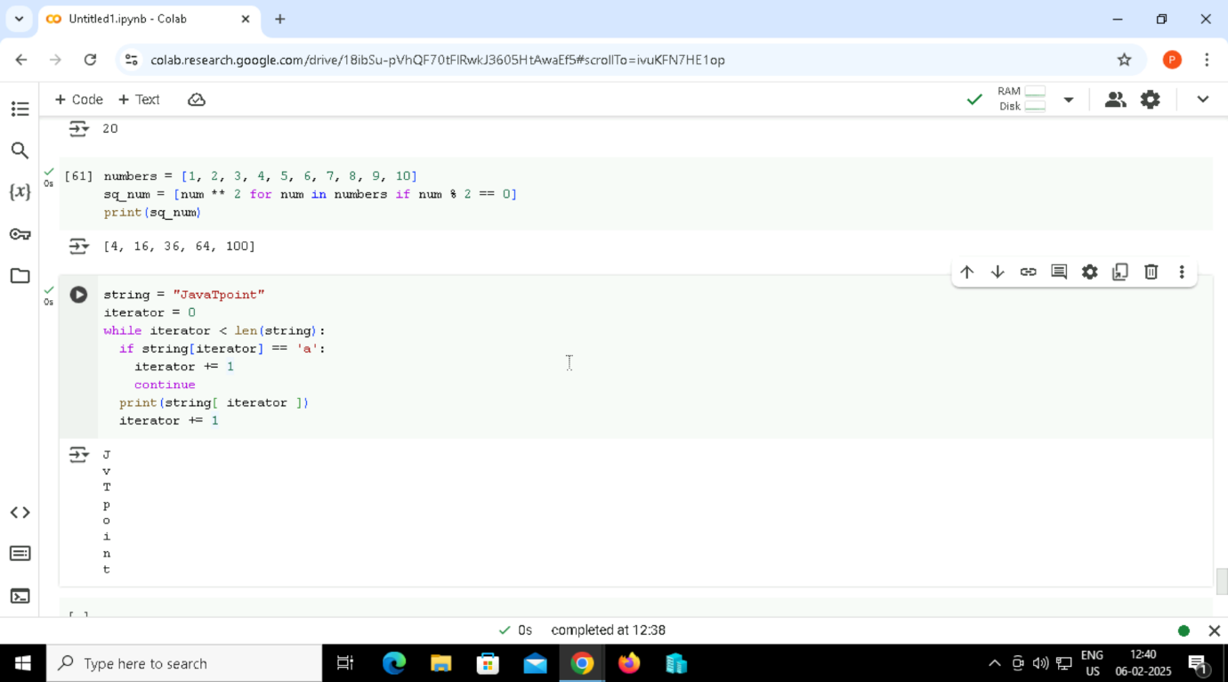

56. Printing numbers from 10 to 20 except 15 can be done using continue statement and for loop.

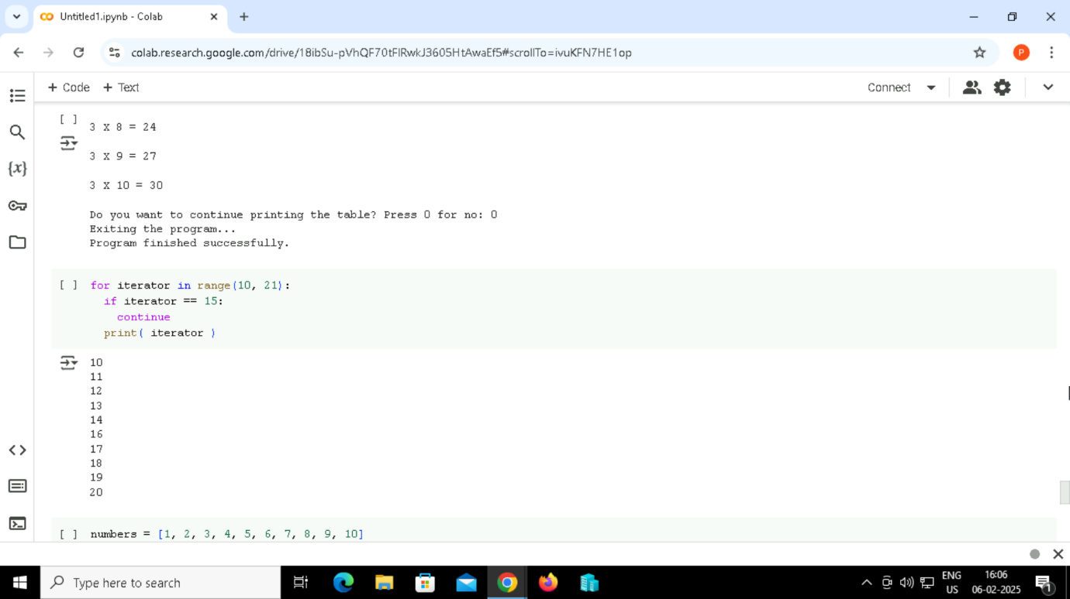

Output:



Python String

57. Creating String in Python

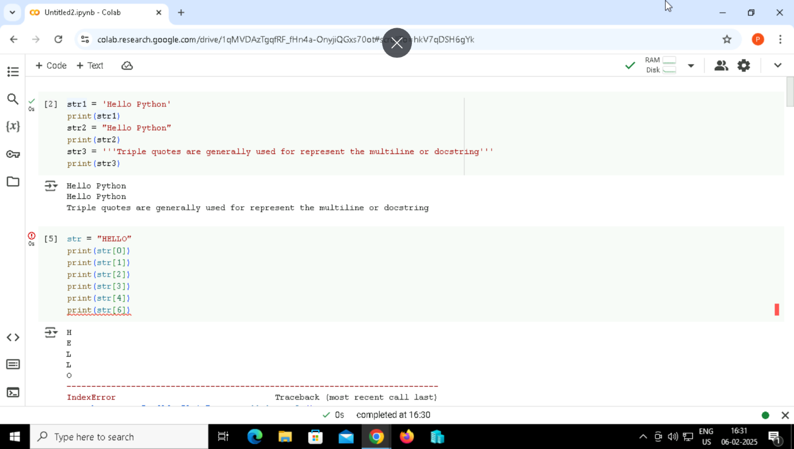

Output:

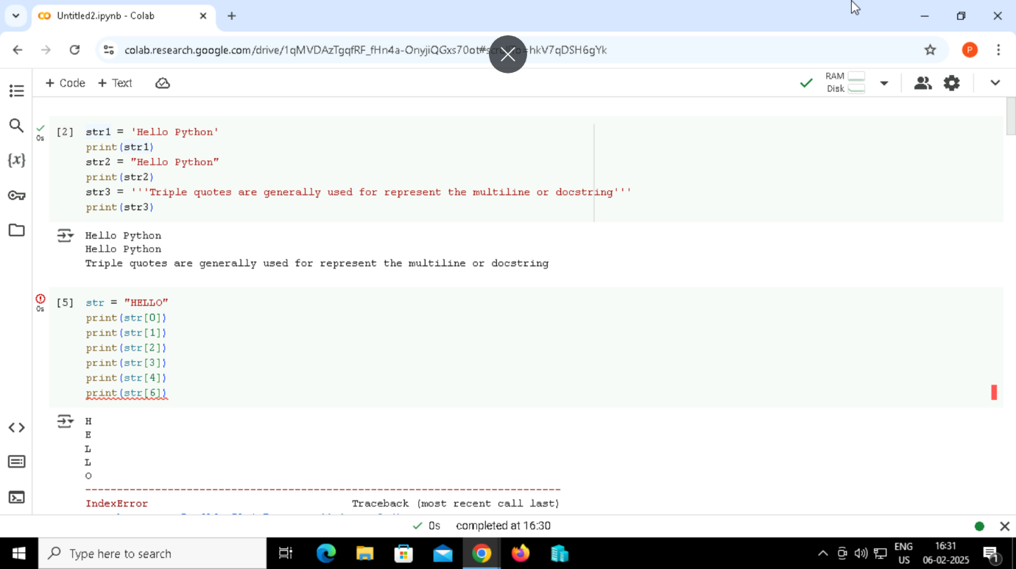

58. Strings indexing and splitting

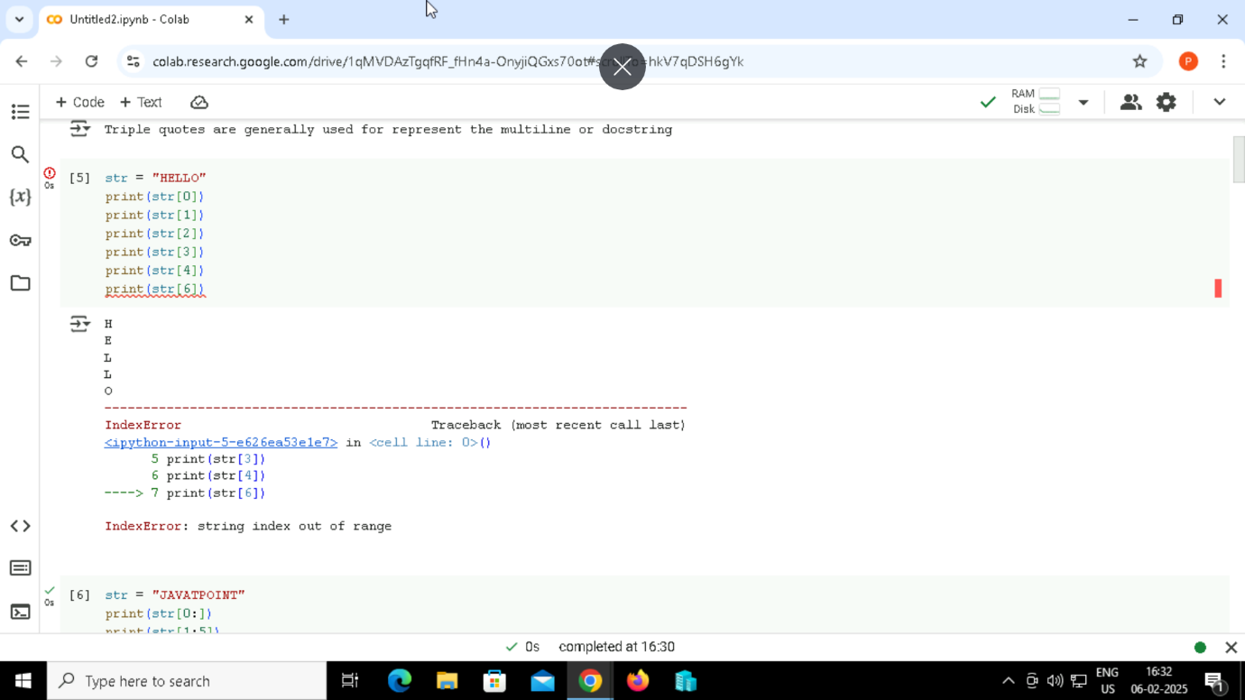

Output:



59. Strings indexing and splitting

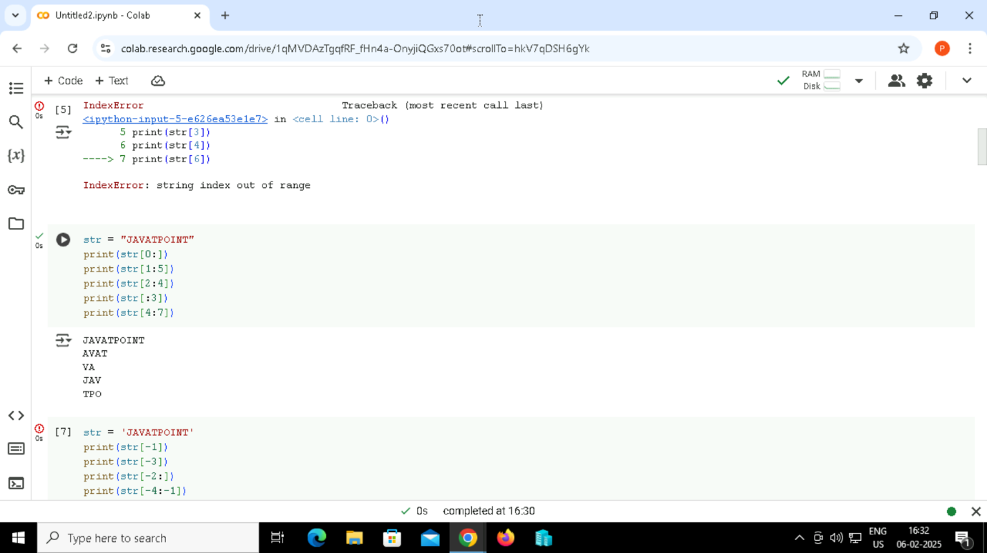

Output:

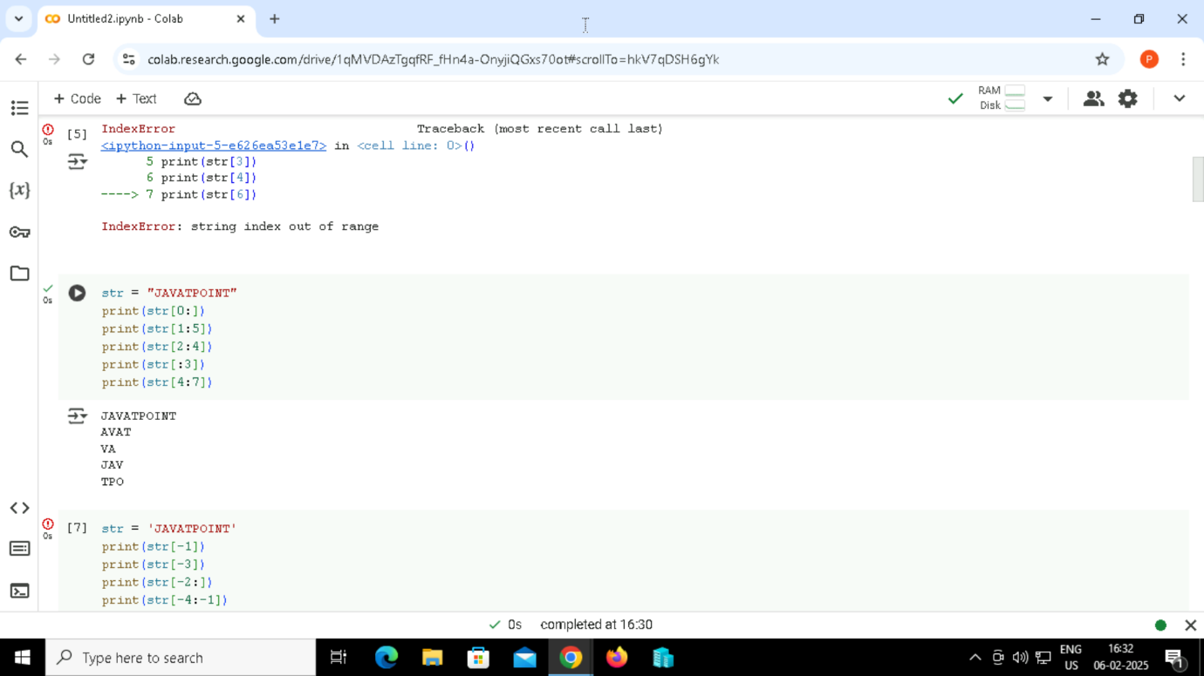

60. Strings indexing and splitting

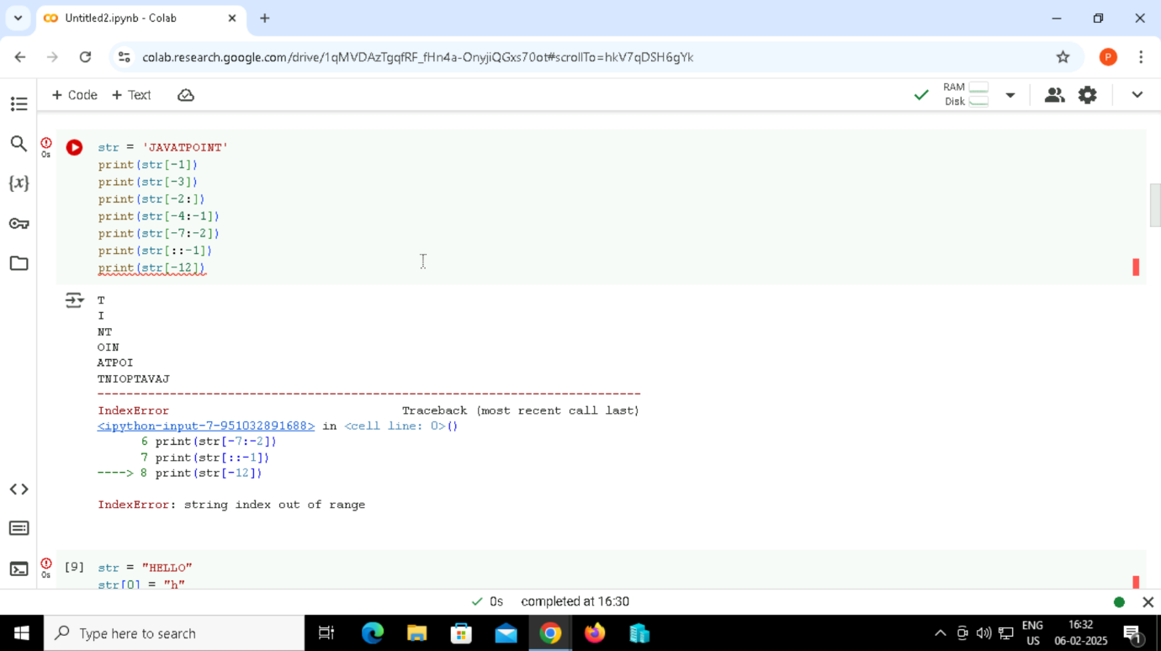

Output:

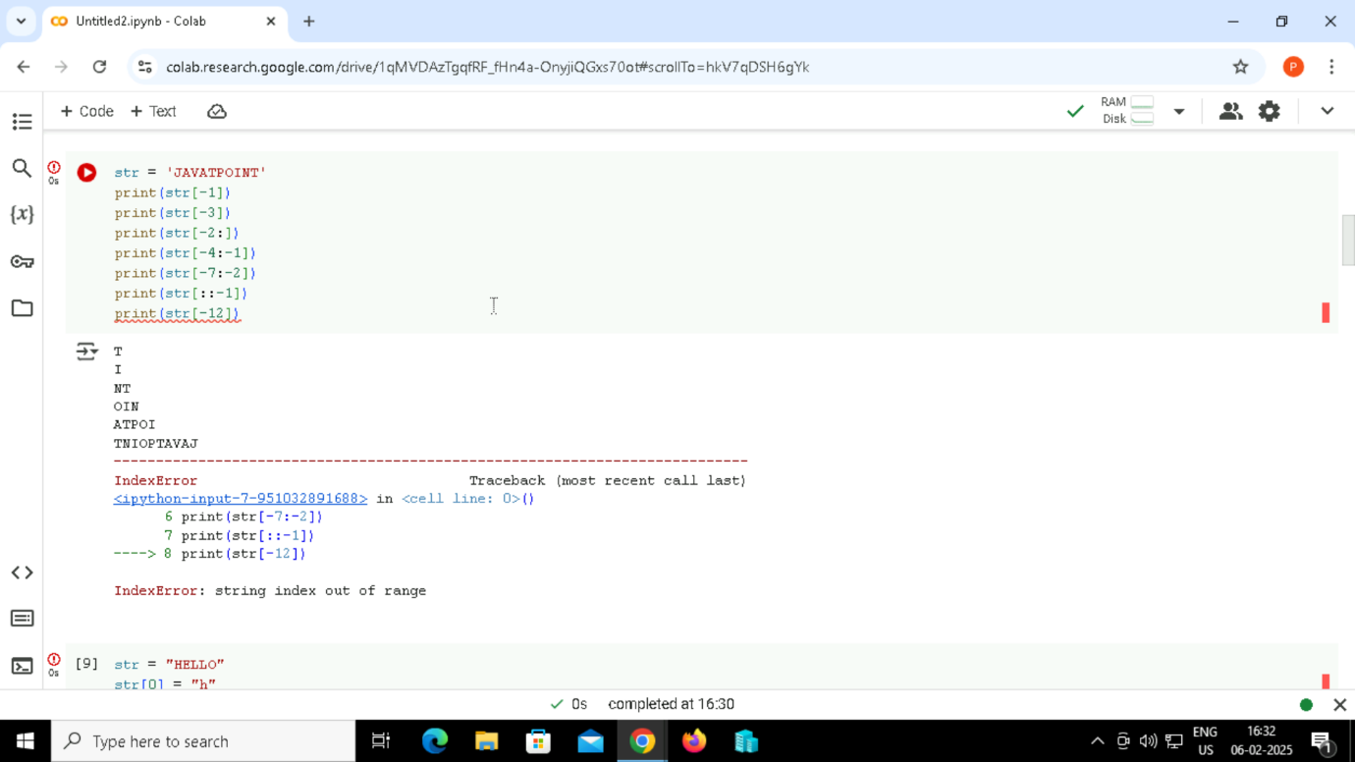

61. Reassigning Strings

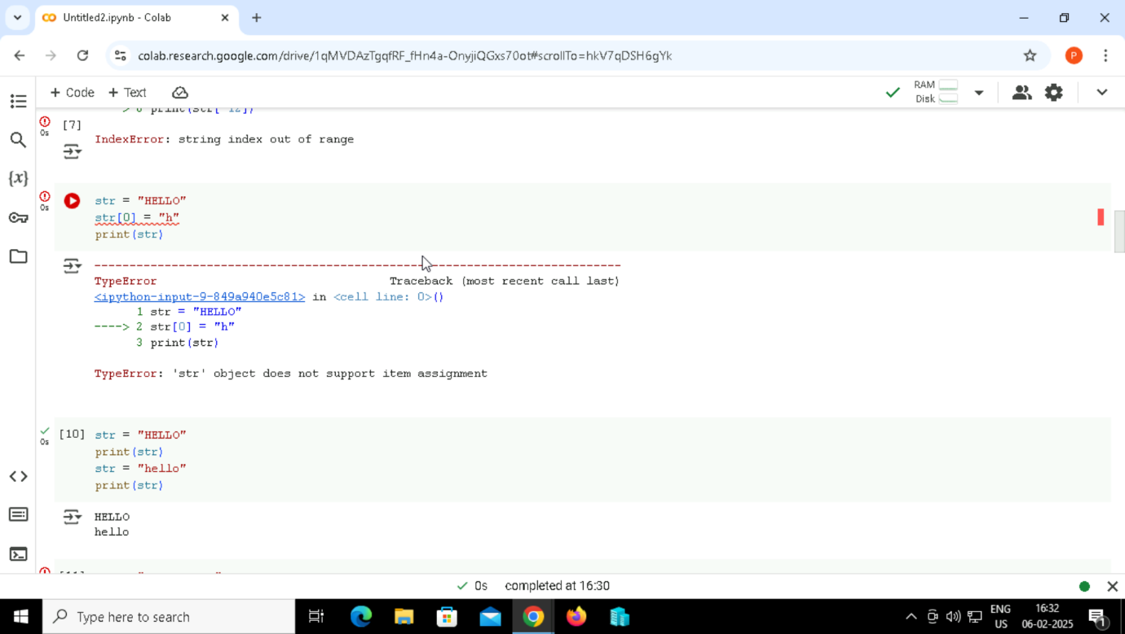

Output:

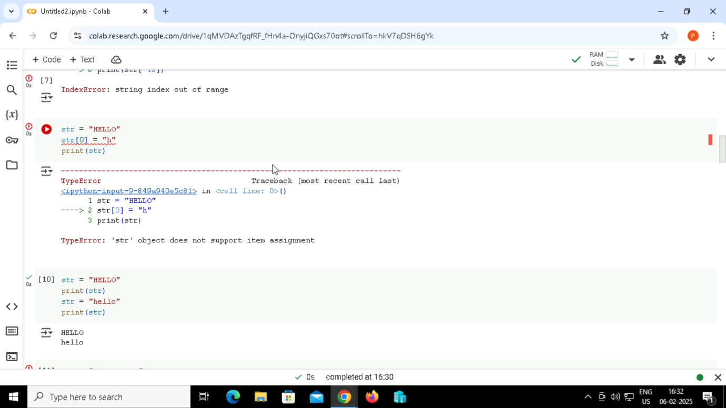

62. Reassigning Strings



Output:

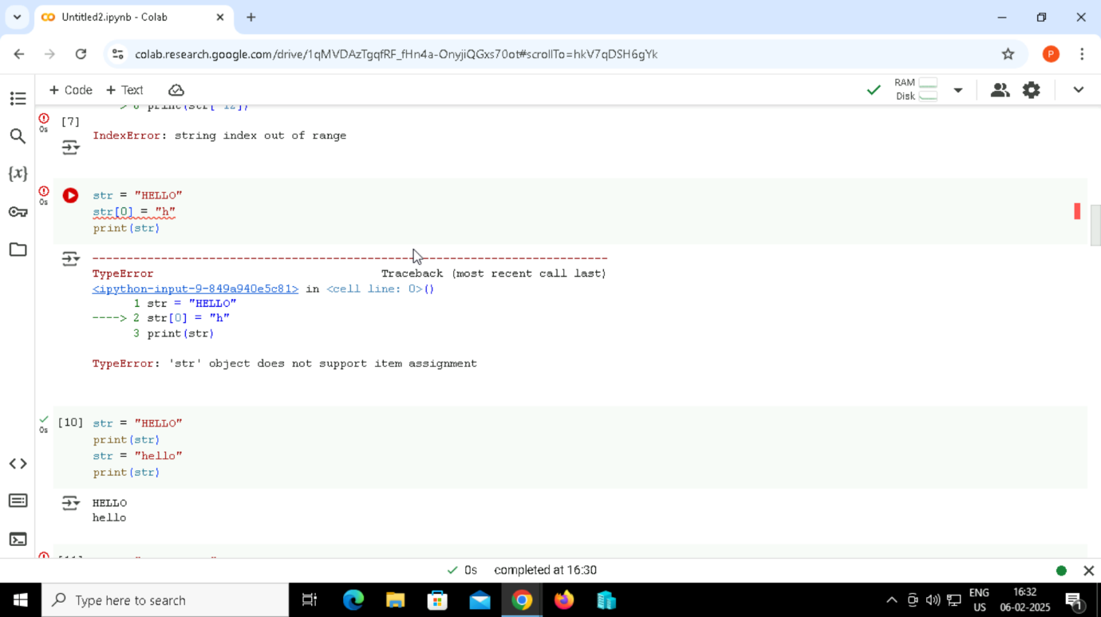

63. Deleting the String

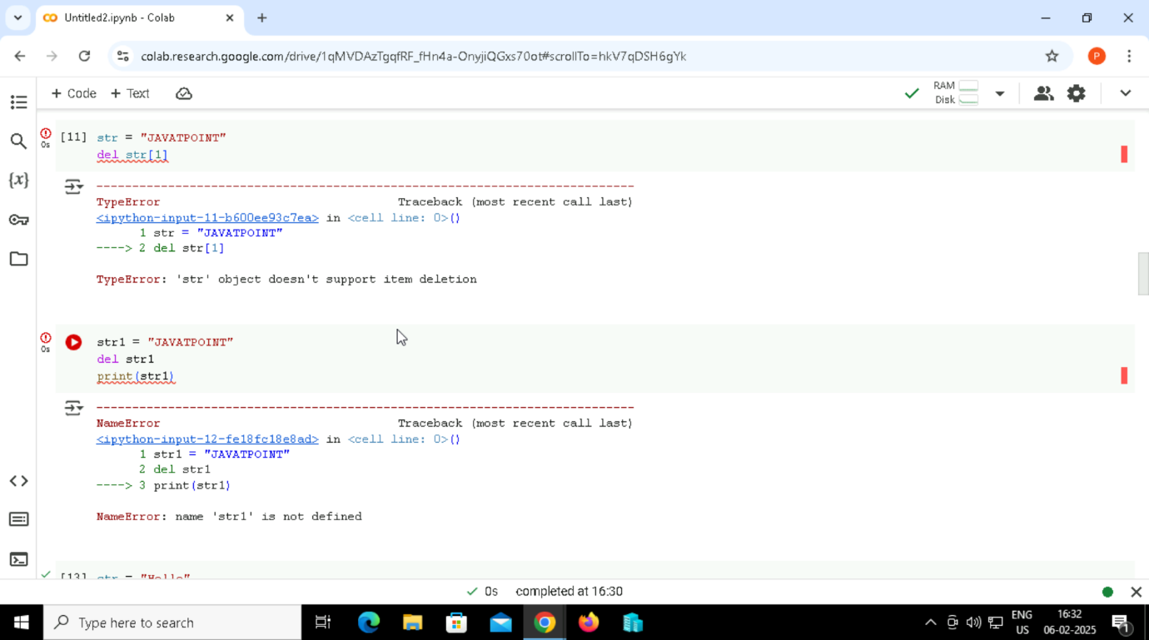

Output:

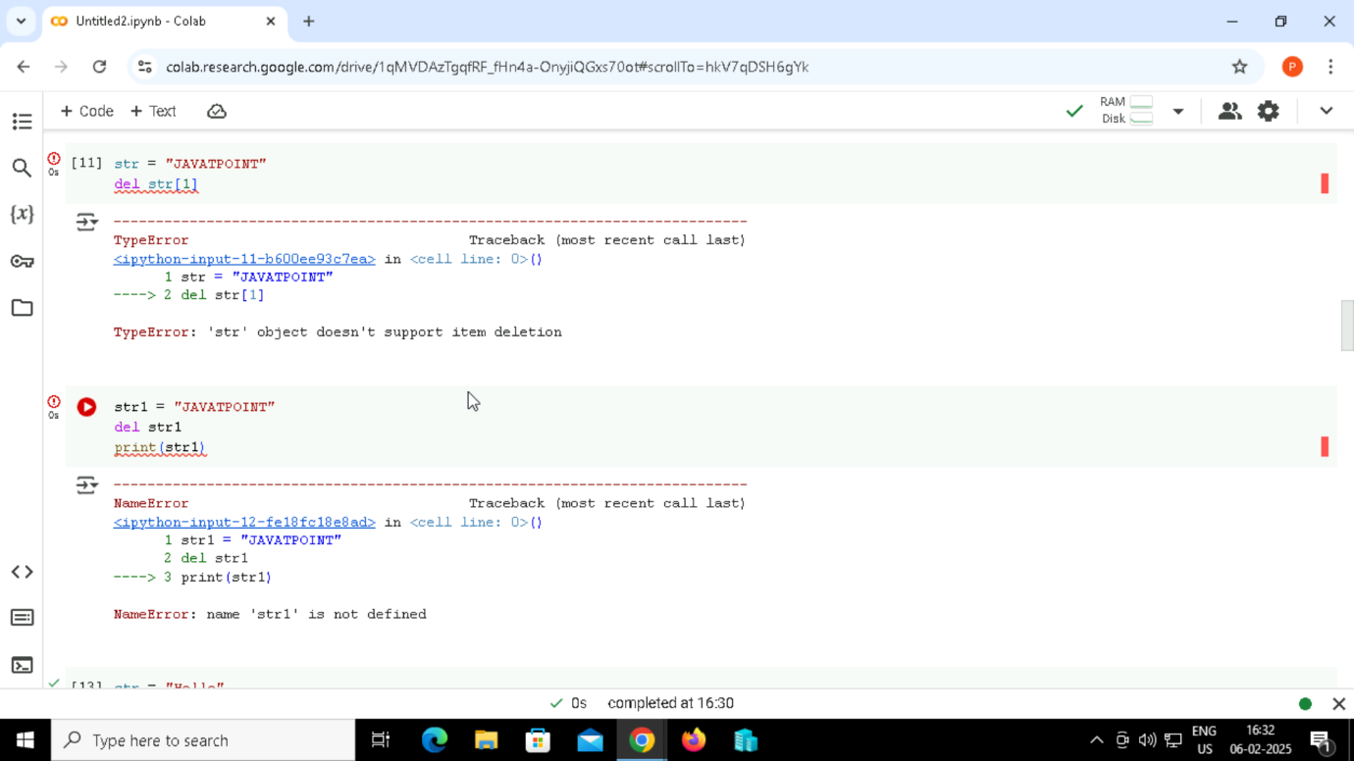

64. Deleting the String



Output:

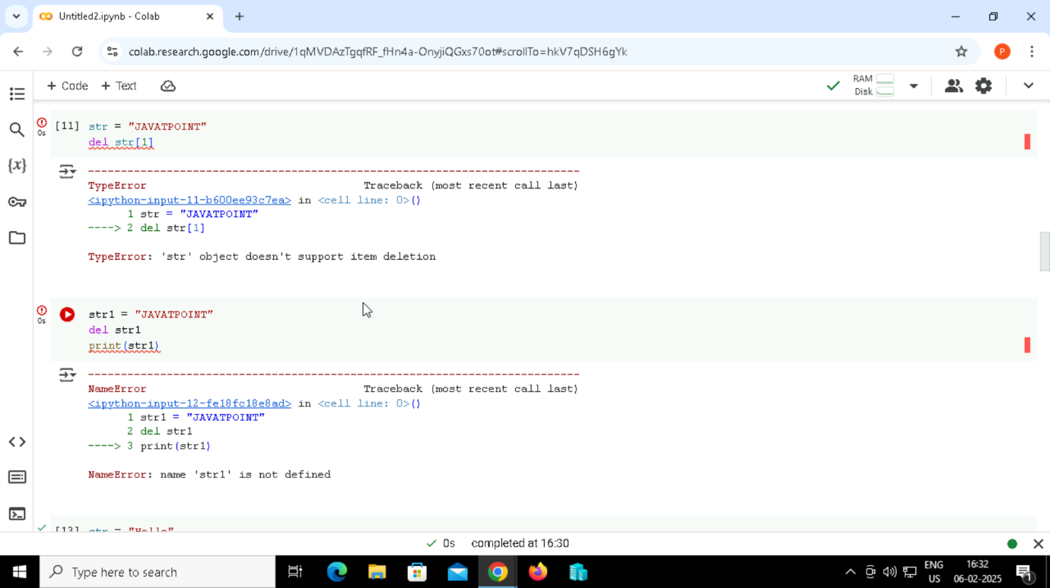

65. String Operators

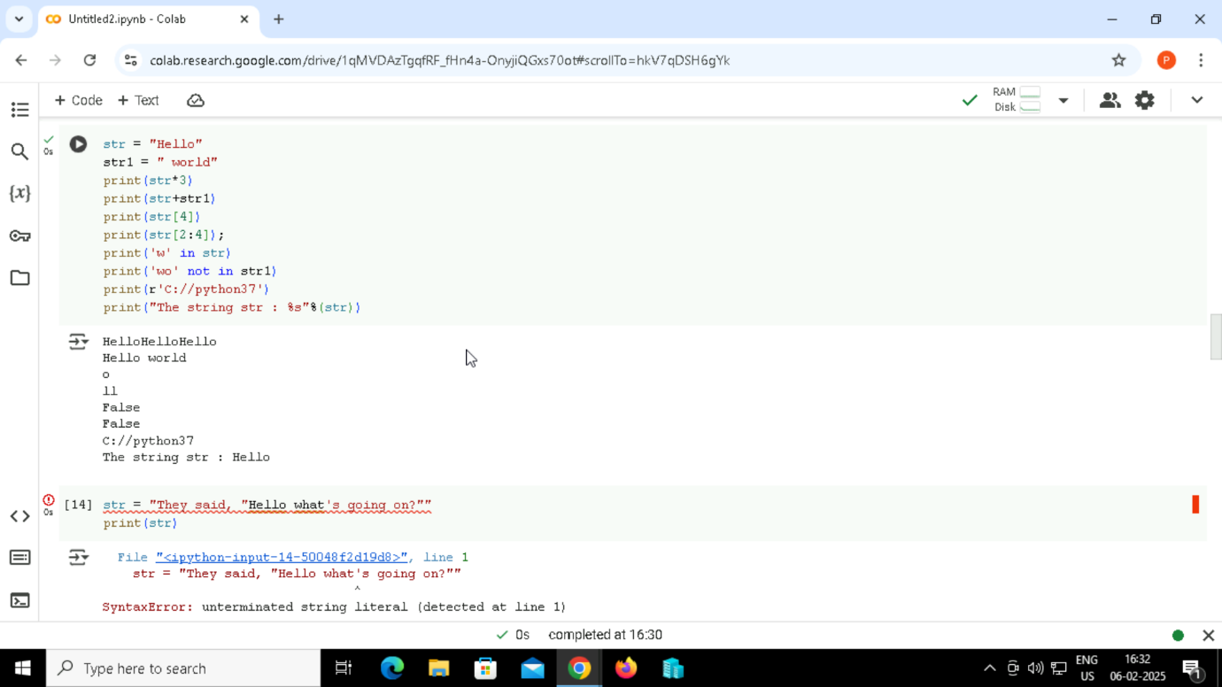

Output:



Python String Formatting

66. Escape Sequence



Output:

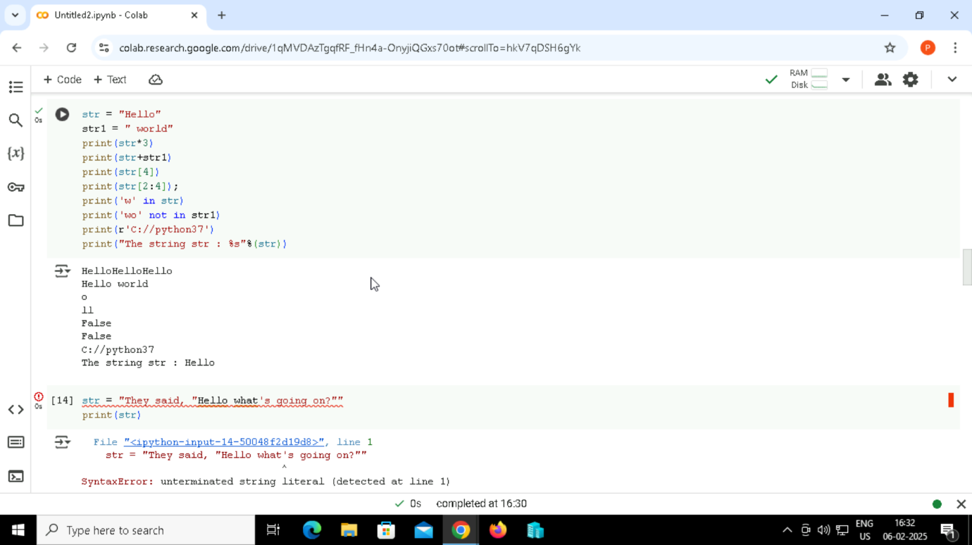

67. Escape Sequence

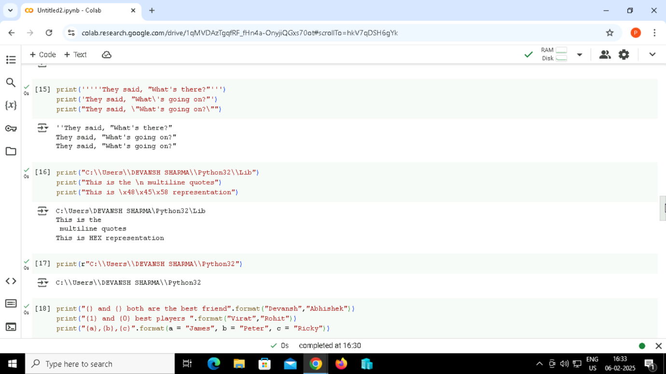

Output:

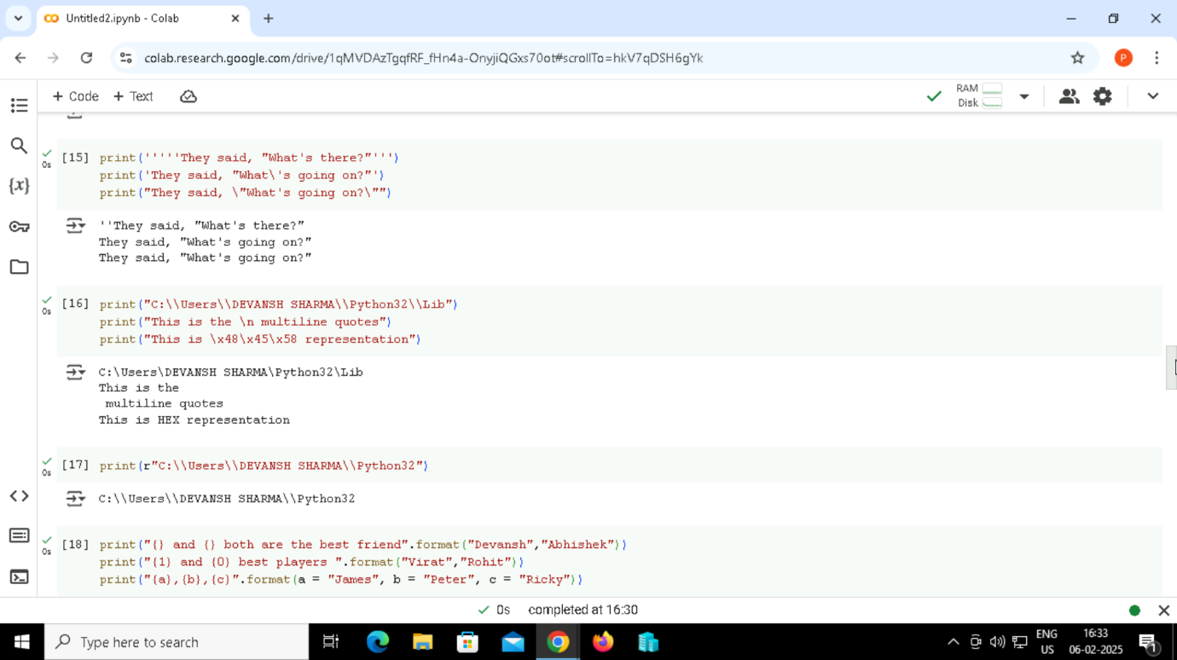

68. Escape Sequence



Output:



69. Escape Sequence



Output:



70. format() method

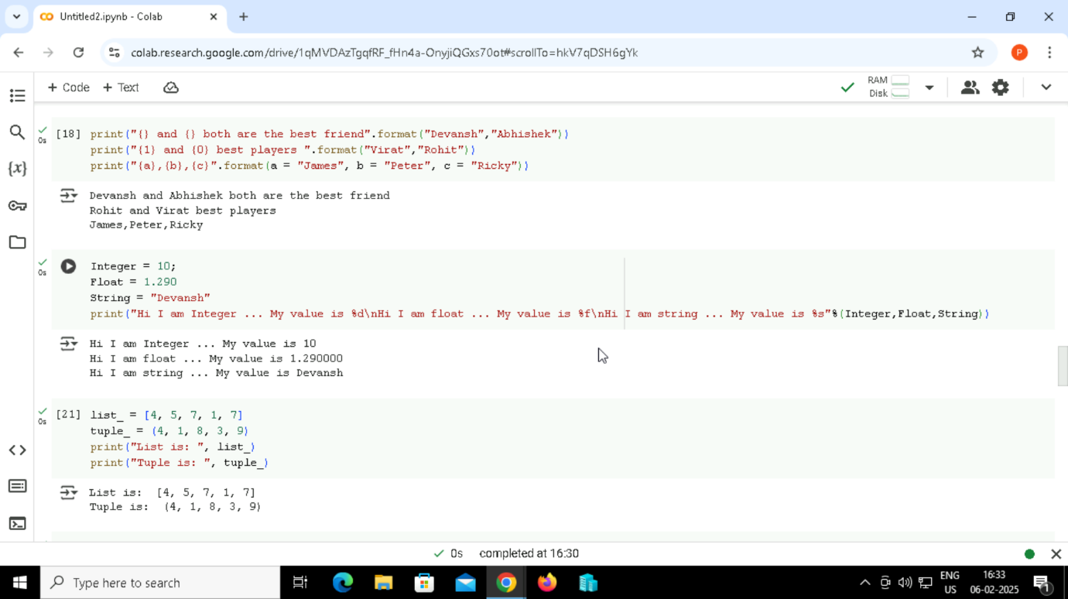

Output:

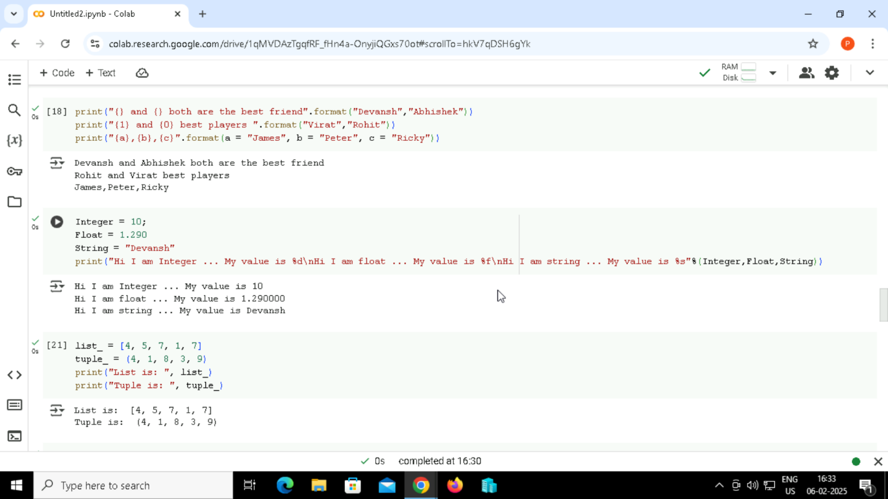

71. String Formatting Using % Operator



Output:



72. Python code to show the difference between creating a list and a tuple.



Output:



73. Code to print the data type of the data structure using the type() function.

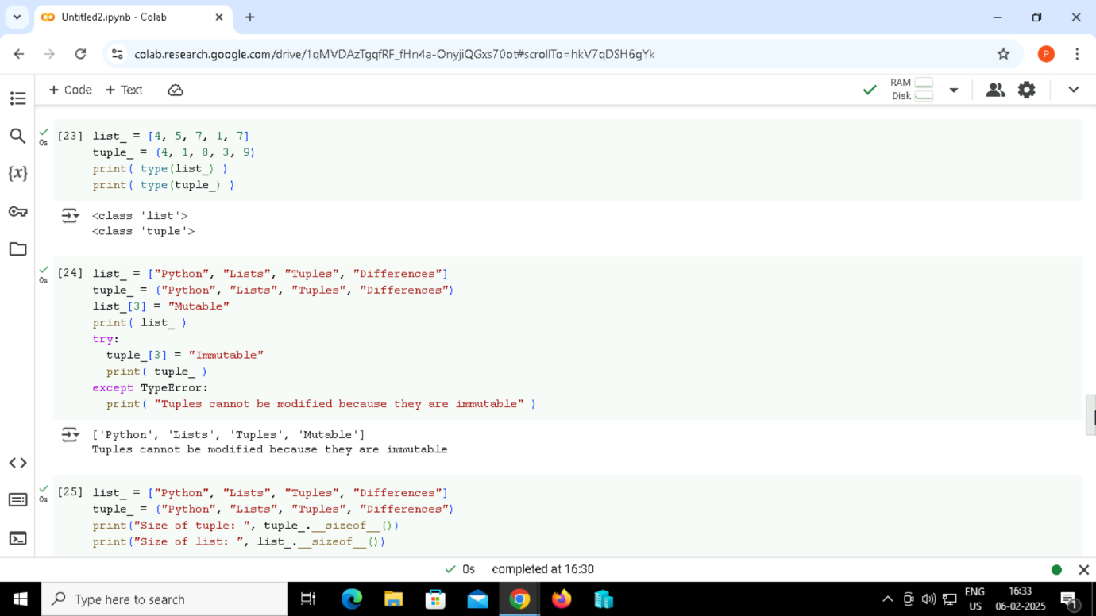

Output:

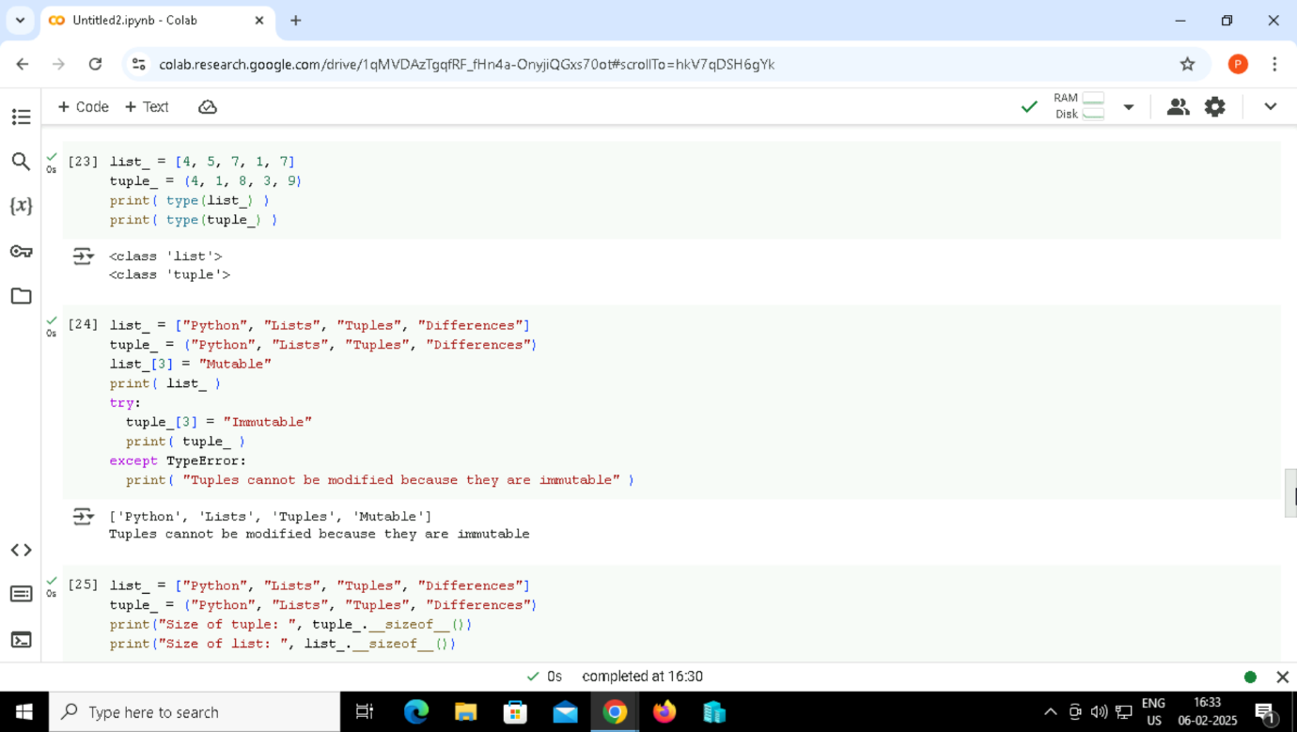

74. Updating the element of list and tuple at a particular index.



Output:

75.

75. Code to show the difference in the size of a list and a tuple

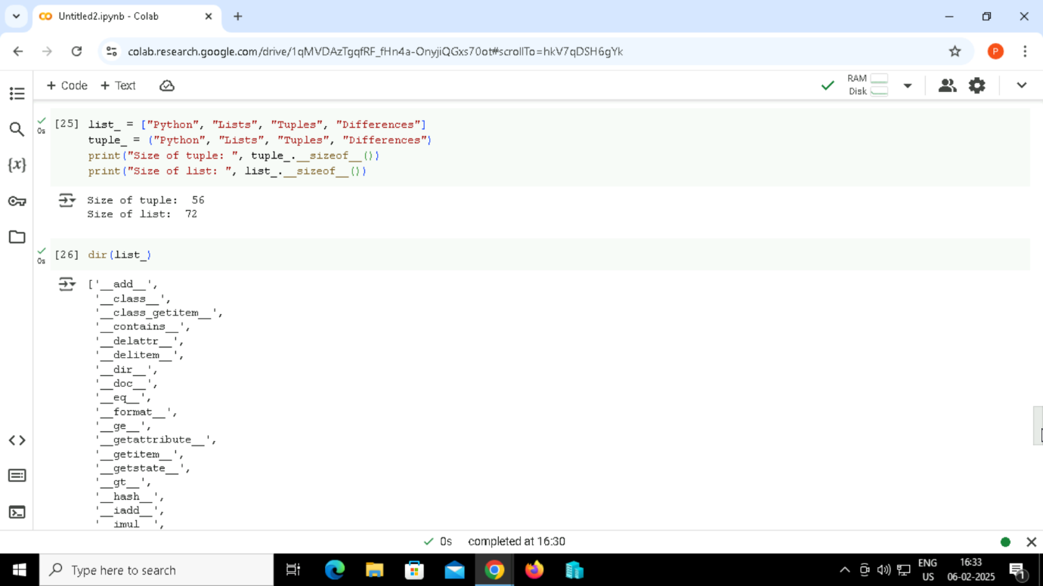

Output:



76. Printing directory of list.



Output:



77. Printing directory of a tuple.

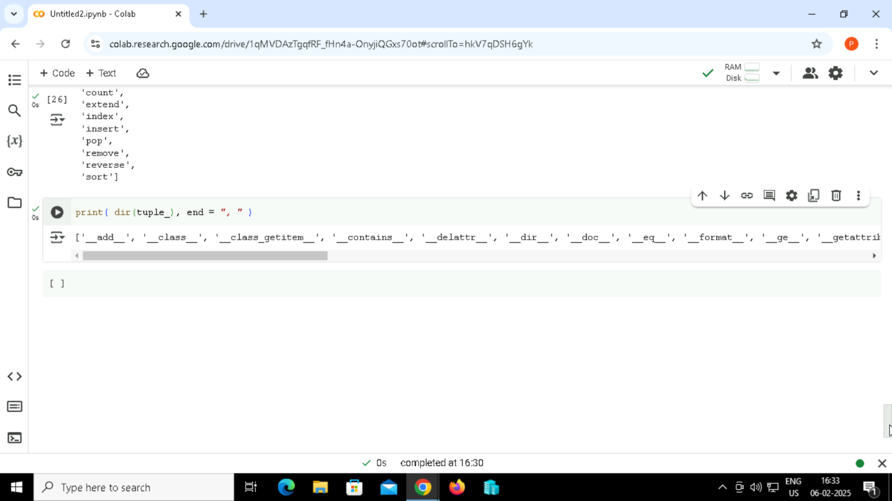

Output:

